

Revo Uninstaller Pro 4
User's Guide
(Document last update - 11 September 2018)

1. Overview 5
2. User Interface 8
3. Uninstaller 12
3.1. All Programs 12
3.1.1. Uninstall 14
3.1.2. Quick Uninstall 19
3.2. Traced Programs 20
3.2.1. Uninstall 21
3.2.2. Custom Uninstall 22
3.2.3. Advanced Uninstall 25
3.2.4. Manage 27
3.3. Windows Apps 30
3.4. Browser Extensions 32
3.5. Logs Database 34
3.6. Forced Uninstall 35
3.7. Install Programs 39
3.8. Hunter Mode 41
4. Backup Manager 42
5. Tools 43
5.1. Autorun Manager 43
5.2. Junk Files Cleaner 46
5.3. Windows Tools 48
5.3.1. System Restore 50
5.3.2. Network Diagnostics 50
5.3.3. Network Information 50
5.3.4. Security Center 50
5.3.5. System Properties 50
5.3.6. System Information 51
5.3.7. TCP/IP Netstat Command 51
5.3.8. On-Screen Keyboard 51
5.3.9. Disk Defragmenter 51
5.3.10. Services 52
5.3.11. Shared Folders 52
5.3.12. Group Policy 52
5.3.13. Add/Remove Windows Components (Windows Features) 52
5.3.14. Microsoft Windows Malicious Software Removal Tool 53
5.3.15. Windows Backup and Restore 53
5.3.16. Task Scheduler 53
5.3.17. Check Disk 53
5.3.18. System File Checker 54
5.3.19. Disk Cleanup 54
5.3.20. Resource Monitor 54
5.4. History Cleaner 55
5.5. Evidence Remover 57
5.6. Unrecoverable Delete 58
6. Options 59
6.1. General 60
6.2. Uninstaller 60
6.2.1. General 60
6.3. All Programs 61
6.3.1. General 61
6.3.2. Registry 62
6.3.3. Folders 63
6.4. Traced Programs 63
6.4.1. General 63
6.4.2. Exclude 63
6.4.3. Processes 64
6.5. Logs Database 65
6.6. Groups Manager 65
6.7. Junk Files Cleaner 65
6.7.1. General 65
6.7.2. Exclude 66
6.7.3. Include 66
6.8. View 66
6.8.1. General 66
6.8.2. Theme 67
7. Registration/Activation and Update Subscription 67
7.1. Activate Online 68
7.2. Activation by File 70
7.3. Deactivate 71
8. Command Line support 71
9. Restore Full Registry Backup 73
9.1. Windows Vista and Windows 7 73
9.2. Windows 8 and Windows 10 75
10. Frequently Asked Questions (FAQ) 76
10.1. General questions 76
10.2. Registration and licensing questions 78
10.3. Uninstall (remove) programs related questions 79
10.4. Logs Database module related questions 82
10.5. Questions related to other cleaning or optimization tools 83

- Overview

Revo Uninstaller Pro helps you uninstall software and remove unwanted programs, apps and browser extensions installed on your computer, even when you have problems uninstalling and cannot uninstall them from the "Programs and Features" and/or “Apps and features” applets in Windows.

Revo Uninstaller Pro is a much faster and more powerful alternative to the "Programs and Features" and “Apps and features” applets. It allows you to efficiently manage your installed programs and apps.

Programs can leave a lot of data in your computer after their removal. There are tens of thousands of applications that leave a lot of unused data, such as Registry entries, files and folders. Not all leftover Registry entries in your computer can be classified as errors, so third party Registry cleaners cannot detect them. Leftover Registry entries, in combination with leftover files, make Registry cleaners’ jobs ineffective. Revo Uninstaller Pro helps you remove the Registry entries, files and folders, left by the program you uninstall.

With its advanced and fast algorithms, Revo Uninstaller Pro analyzes the application's data before uninstallation, and scans your computer for leftovers after the built-in uninstaller of the program you are uninstalling finishes. After the program's regular uninstaller runs, you can remove additional unnecessary files, folders and Registry entries, usually left over on your computer.

Even if you have a broken (corrupt) installation of an application, Revo Uninstaller Pro can scan your hard disk drives and Windows Registry, and show all files, folders and Registry entries found, so you can delete them easily.

Using Revo Uninstaller Pro it is also easy to uninstall Windows Apps that come pre-installed with the latest versions of Windows, or are afterwards installed by the user from the Microsoft Store, where you have access to tens of thousands of apps. As with the uninstallation of a program, Revo Uninstaller Pro searches for leftover files, folders, and Registry entries, and allows you to delete them.

There are some programs that mislead you to install unwanted browsers extensions, or do so silently. These browser extensions change your browser settings without your approval, thus compromise your browsing experience. Revo Uninstaller Pro’s “Browser Extensions” module lets you remove such unwanted add-ons from the most popular browsers – Microsoft Edge, Microsoft Internet Explorer, Google Chrome and Mozilla Firefox.

Revo Uninstaller Pro also has a very powerful feature called Forced Uninstall. With it you can remove leftovers of programs that are already uninstalled, incomplete installations, and remnants of programs. It does not matter if the program you want to remove is not listed in the "Programs and Features" or “Apps and features” applets. Forced Uninstall is the best solution when you have to remove partially installed or uninstalled programs, and programs not listed as installed at all.

With its Hunter mode, Revo Uninstaller Pro offers you simple, easy to use, yet effective and powerful software removal features. You can use it to manage your installed and/or running programs directly from your Desktop, using their icons or opened windows.

Revo Uninstaller Pro has another feature, which allows monitoring an installation of a program for a complete removal. Revo Uninstaller Pro detects changes done to the system in real-time, during the installation of the program itself: it records what files, folders, and Registry entries are created, deleted, and modified. This feature is also very powerful, because by monitoring system changes during the installation, we eliminate the necessity of all scanning algorithms applied during the uninstallation. You can use the installation log for a complete removal of the program, just as if it had never been installed at all.

The Import Log and Export Log commands let you easily share logs with anyone using Revo Uninstaller Pro, thus being sure you are doing the ultimate uninstall of the programs you have installed. For example, if you have problems uninstalling Program A or just want to do a better uninstall of it, and a friend of yours has installed and traced the same program, and has a log, he can just export the log, and send it to you. You can then import it, and use it to uninstall the program just as if you had traced its installation yourself.

Another important part of Revo Uninstaller Pro is the Logs Database. It is a database of logs of programs, traced through the monitoring module of Revo Uninstaller Pro, and managed by Revo Uninstaller Pro's team. Those logs are stored on our web site, and you can easily (one click only) use them to uninstall a program with its respective log, or to remove leftovers of a previously uninstalled program.

For the best uninstallation experience there is an integration between the installed programs, the user-made logs of traced programs, and the Logs Database, so when you start uninstalling a program, Revo Uninstaller Pro will search for the best possible way to uninstall said program, and decide if a log, if any, whether traced by the users or maintained by Logs Database, can be used for the task.

Revo Uninstaller Pro has a multi-level backup system. The Backup Manager is the main part of that system. It helps you manage backup information stored by Revo Uninstaller Pro, such as deleted Registry entries, files, and folders. The other levels of the backup system are:
- Creating a System Restore Point before each uninstallation
- Full Registry backup before each uninstallation
- Full Registry backup once a day, if Revo Uninstaller Pro is started.

Revo Uninstaller Pro gives you another 8 handy and powerful tools to clean up your system. Here is the list of the tools and utilities included in Revo Uninstaller Pro:

Autorun Manager - Stop programs, services, and scheduled tasks that start automatically with Windows, thus speeding up the loading of the operating system.

Junk Files Cleaner - Find and remove unnecessary files from your computer; free up disk space, and delete files you do not need.

Windows Tools - Handy and useful tools bundled with every version of Windows; easily find useful system tools and options.

History Cleaner – This module allows you to clean data at once or separately in three cleaning sub-modules. Browsers Cleaner allows you to clear the visited pages and address bar history, delete cookies and temporary Internet files (cache) of the following web browsers: Edge, Internet Explorer, Firefox, and Opera; free up a lot of disk space by deleting temporary Internet files like cached videos, Flash files, images, etc. Windows Cleaner allows you to clear the history of recently opened files in various programs, delete temporary Windows files, empty the Recycle Bin, delete unnecessary crash dump files, etc. Microsoft Office Cleaner allows you to clear the history of the most recently used files in Microsoft Office.

Unrecoverable Delete - Erase files and folders forever; be sure that nobody could recover your files and folders after their deletion.

Evidence Remover - Make sure already deleted files, folders and other data are unrecoverable by wiping the free space on your hard drives; securely erase your data.

- User Interface

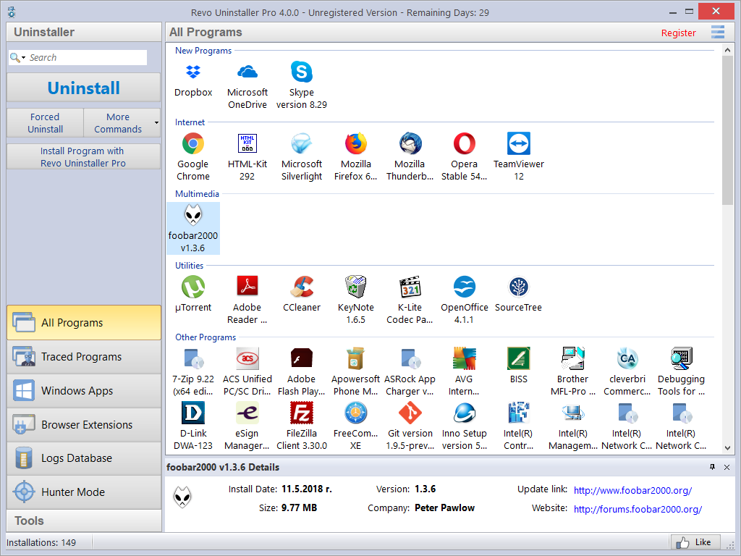

The main window of Revo Uninstaller Pro is divided into a few user interface components. On the left part of the window is the Commands Panel, which is also divided into two parts. The upper part contains the available commands for the currently active tool. The main and most frequently used commands for each tool are shown as separate buttons, all others commands are in the “More commands” button, or in the context menu when right clicking inside the tool window. The lower part of the Commands Panel contains all the tools and modules included in Revo Uninstaller Pro. They are logically separated in two groups – Uninstaller and Tools, and can be switched through a button with that caption located on the lower part of the Commands Panel. Clicking that button loads the buttons for the appropriate group. To open a module, you just have to click its button. Its commands will be displayed above, and its main data window will be loaded in the central part of the entire Revo Uninstaller Pro window.

On the upper right part of the main window of Revo Uninstaller Pro is located the Menu button. It shows a menu with some essential, general commands for the whole program.

At the bottom of the main window is the Status Bar. It may show additional information, depending on the currently active tool/module.

The Description Panel is by default located above the status bar. It shows common information about the active tool. It can be moved by dragging (pressing and holding the left mouse button anywhere in its window). The Description Panel also supports an “auto hide” feature that hides and shows the panel on mouse over. To activate/deactivate the “auto hide” option press the small button with the shape of a pin in the upper right part of the Description panel.

When either the All Programs or Traced Programs module is activated, and the shown list is in Icon or List mode, the Description Panel is used as a Details Panel when an item is selected, thus showing some of the important properties of the selected item.

Keyboard shortcuts
Command | Hotkey
Options | Alt+O
Hunter Mode | Alt+H
Exit | Alt+X
All Programs | Alt+U
Uninstall | Ctrl+U
Quick Uninstall | Ctrl+Q
Refresh | Ctrl+R
Forced Uninstall | Ctrl+F
Install Programs | Ctrl+L
Print | Ctrl+P
Print Preview | Shift+P
Print Setup | Ctrl+Shift+P
Traced Programs | Alt+T
Uninstall | Ctrl+U
Custom Uninstall | Ctrl+C
Refresh | Ctrl+R
Edit Log | Ctrl+D
Install Programs | Ctrl+L
Import Log | Ctrl+I
Export Log | Ctrl+E
Print | Ctrl+P
Print Preview | Shift+P
Print Setup | Ctrl+Shift+P
Windows Apps | Alt+W
Uninstall | Ctrl+U
Refresh | Ctrl+R
Browser Extensions | Alt+R
Uninstall | Ctrl+U
Refresh | Ctrl+R
Logs Database | Alt+L
Uninstall | Ctrl+U
Custom Uninstall | Ctrl+C
AutoRun Manager | Alt+A
Run | Ctrl+N
Kill | Ctrl+K
Add | Ctrl+A
Remove | Ctrl+M
Disable | Ctrl+D
Refresh | Ctrl+R
Junk Files Cleaner | Alt+J
Scan | Ctrl+S
Delete | Ctrl+D
Windows Tools | Alt+T
Run | Ctrl+R
History Cleaner | Alt+C
Clear | Ctrl+C
Clear All | Ctrl+A
Evidence Remover | Alt+E
Execute | Ctrl+E
Unrecoverable Delete | Alt+D
Delete Forever | Ctrl+D
Add File(s) | Ctrl+F
Add Folder | Ctrl+Shift+F
Backup Manager | Alt+B

- Uninstaller
  - All Programs

When Revo Uninstaller Pro is started, its main window displays installed programs on your computer. Depending on the settings, other items such as system updates or system components may also be listed. Depending on the view setting, programs are displayed as Icons, a List, or in a table with Details such as Name, Size, Version, Type, Installation Date, Company, Comment, Uninstall String, Registry Key (hidden by default) and Website.

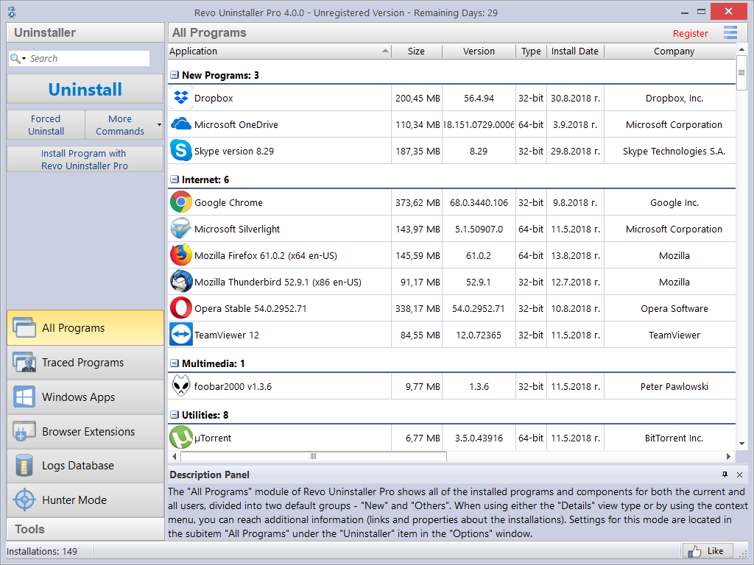

By default, installed programs are displayed in Details view. You can right click on the column header to sort, and you can show or hide some of the columns. This way you can also choose what to print. Printing works only in Details view, which is why it is better to setup printing in landscape mode, as that would contain much more information. Using the commands in the context menu, you can also change the alignment of the text in each column.

In Icons view, when you select a program, some of the properties of the program (like Icon, Size, Version, Install Data, Company, Update Link and Web Site, are shown in the Description Panel. You may also see similar data when you hover the mouse cursor over a program in the list. In that case, the data is shown as a tooltip, next to the mouse cursor.

By default, Revo Uninstaller Pro displays programs in in two groups:
New programs – programs installed in the last 7 days (the number of the days can be changed in the options) or since the last run of Revo Uninstaller Pro;
Other Programs – all programs installed before the last 7 days, or before the last run of Revo Uninstaller Pro.
You can assign each program to a group by using the context menu when right clicking on a program. Removing a program from a group is also possible from the same context menu. The default groups are Internet, Games, Multimedia and Utilities. Additional groups can be added from the Groups Manager in the Options, or directly from the context menu: Add to Group -> Add new group.
The selected (right clicked) item will be automatically moved to the newly added group.

Using the Search field in the upper right part of the Commands Panel, you can filter the program list by name, publisher, or comment. You can choose the search criteria from the drop-down menu shown after clicking the magnifying glass. The program list will be filtered in real-time as you type. When searching, the status bar will display the number of found programs that match the search criteria.

Revo Uninstaller Pro has a command to export installed programs to TXT, HTML and XLS (Microsoft Excel spreadsheet). To use the command, click More commands -> Export List to. You can choose what information will be included in the exported file.

NOTE: To export installed programs to a Microsoft Excel spreadsheet you must have Microsoft Excel installed and working properly.

Some other commands available from the context menu are:
Search at Google for – use it to search online using Google for the application’s name or publisher. This will open your default web browser and display the results of the search.
Open About Link – opens your default web browser and loads the address providing more information about the program, if such exists.
Open Help Link – opens your default web browser and loads the address providing help information for the program, if such exists.
Open Update Link – opens your default web browser and loads the address providing update information for the program, if such exists.
Install Location – opens the location where the program is currently installed in Windows Explorer.
Open Registry Key – opens the Registry editor (regedit.exe) and displays the Registry key containing the uninstallation information for the selected application.
Add/Edit Comment – opens a window to add a comment about the program, or edit an existing one. The comment is visible in Details view.
Change Icon – opens a window to select a new icon for the program displayed in the list. You can browse for an icon in any EXE or DLL file.

If during an uninstallation the built-in uninstaller of a program runs a "Change" or "Repair" command, and tries to reinstall or repair the program instead of uninstalling it, then you can use the Forced MSI Uninstall command. This command is visible in the context menu only for MSI (Microsoft Installer) programs, whose default uninstallation command is not “uninstall”. So if you experience such problem, just cancel both the built-in uninstaller of the program and Revo Uninstaller Pro’s uninstall wizard, and start the uninstallation again using the aforementioned command from the context menu.

In some cases, when a program is selected, depending on the installer of that program, you may see in the More commands menu the command Change or Repair. That command is shown only when the installer of the program supports such functionality. Executing it will open a window letting you change the installed components of the program, or repair its installation in case it does not work properly.

If there are some kind of general problems with the listing of all installed programs, and the Refresh command (located in the More commands menu) does not fix it, you may try to rebuild the cache file that contains the installed programs data. To execute the Rebuild cache file command, you have to open the Options from the Menu button (or press Alt+O on your keyboard), go to the All Programs page, and click the “Rebuild cache file” blue text.

NOTE: Rebuilding the cache file resets any user customization for the program list, so your comments, custom icons, and group associations will be erased. You will see a warning message before rebuilding the cache.

    - Uninstall

The main command you can use for the list of installed programs is Uninstall. Selecting a program and pressing the Uninstall button will bring up the Uninstallation Wizard.
Firstly, in the background, Revo Uninstaller Pro will try to find a matching trace log or logs of the program you are uninstalling. It searches among the logs you have traced or imported, and the logs in the Logs Database. If there is more than one log related to the program you are uninstalling, or you have a log for a previous, you will see a window asking if you want to use the found log(s) during the uninstallation procedure. Otherwise, if there is an appropriate log and Revo Uninstaller Pro is going to use it, you will be notified on the second step of the Uninstallation Wizard, during the initial data analysis.

After the Uninstallation Wizard is displayed, Revo Uninstaller Pro tries to create a full Registry backup (if this is not disabled in the Options) and a System Restore Point, and then runs the built-in uninstaller of the program you are uninstalling. After you have finished uninstallation with the built-in uninstaller, you have to click the Scan button to continue the uninstallation process with Revo Uninstaller Pro.

NOTE: The built-in uninstaller may show up behind other open windows so you may need to cycle between them by using the Alt+Tab key combination – hold the Alt key and press the Tab key.

If while the Uninstallation Wizard is opened the computer is restarted, either at the request of the built-in uninstaller of the program, or for some other reason, Revo Uninstaller Pro will store the uninstallation data, and will offer you to continue the unfinished uninstallation process next time you start it. You will see a message giving you the option to continue the interrupted uninstallation, postpone it, or cancel it altogether.

You can choose from the following the leftover scanning modes:
Safe - performs a scan of the Registry and the hard drive to find leftover items that are safe to delete. This is the safest and fastest mode.
Moderate - includes the Safe mode, and performs an extended scan to find all of the application's leftover information in the most common places of the Registry and the hard drive.
Advanced - includes the Moderate mode, and performs a deep and thorough scan to find all of the application's leftover information in the Registry and on the hard drive. This is the slowest mode.

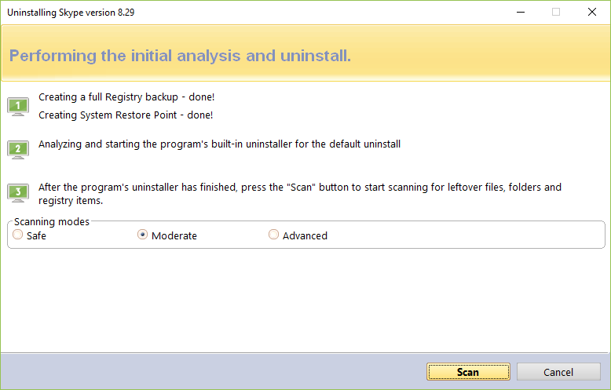

Pressing the Scan button will trigger scanning for leftovers, and the results (if any) will be displayed automatically. Revo Uninstaller Pro shows found leftover Registry entries first. Registry keys and values found as created by the uninstalled program are in bold. Entries that are NOT in bold are considered as not created by the uninstalled program. You can safely check them (leave them checked), as they will not be deleted! Entries not in bold are displayed for two reasons: 1) for information: to give you a better idea of the tree structure, and 2) to make selecting leftovers for deletion easier and faster. You can simply check an entire parent branch, as that will automatically select all of its children. This eliminates the need to check each individual leftover item manually and separately. So, again, whatever items you check, when you press the Delete button, only entries that are checked and in bold will actually be deleted. This applies to when the Select All button is used as well.

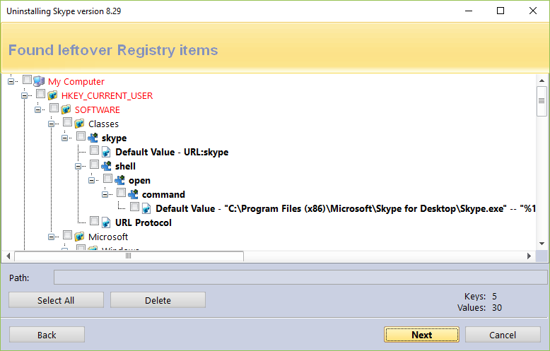

Deleted Registry entries are backed up, so if you need them later you can restore them using the Backup Manager.

Revo Uninstaller Pro uses advanced algorithms to find leftovers related only to the uninstalled program. In some cases however, these algorithms, especially in Advanced leftover scanning mode, could list some items related other programs. One scenario when this can occur, although not always, is when you have installed two or more versions or editions of a program, for example "Adobe Photoshop CS" and "Adobe Photoshop CS5". In this case, the user can distinguish leftovers. It could also happen if you want to uninstall only one component of a larger software package (e.g. a component of Microsoft Office). In that case, Revo Uninstaller Pro could list the rest of the components as leftovers, because they are installed in the same folder, and Revo Uninstaller Pro cannot distinguish the removed component’s leftovers from the other components’ (Word, Excel, PowerPoint, etc.). It is better to use Revo Uninstaller Pro to remove the entire software package instead of a single component.
Revo Uninstaller Pro also includes safety mechanisms, and does NOT list certain leftovers if it decides that deleting them can harm your system. Therefore, although it does a better job than Windows’s “Programs and Features” and “Apps and features” applets, and the built-in uninstaller of the application you want to uninstall, it may still miss some leftovers due to safety precautions and the leftover scanning mode you choose - Safe, Moderate, or Advanced.
In Revo Uninstaller Pro we have implemented many protections to make it safer and more secure, while trying to maximize its accuracy in searching for leftovers.
You can easily distinguish the leftovers (by name, by install path, etc.) and in most of the cases the Select All button can be safely used. There are GUIDs and CLSIDs (alphanumeric items) which are proper leftovers in 99% of the cases, so you can safely delete them.
Note that Revo Uninstaller Pro creates a full Registry backup, a System Restore Point, and backs up every item you delete.
In case you want to change the scanning mode, you can click the Back button, and return to the previous step, select different scanning mode, and press Scan again to continue.

There is also a context menu, which you can bring up by right clicking on leftover items:
Expand All – expands all items in the Registry tree – by default it is expanded so you should not see any difference the first time you use this command.
Collapse All – collapses all items in the Registry tree.
Export All – export shown leftover data to an HTML file.
Expand selected key – expands the selected key and its sub items.
Collapse selected key – collapses the selected key and its sub items.
Uninstall selected key – deletes the selected key from the system.
Mark selected key as Created – marks the selected key as created by the program you are uninstalling. This feature is useful when you see a Registry key, which you are sure is created by the program but is not marked as created because of the safety algorithms in Revo Uninstaller Pro.

Warning: Be very careful using this command. Mark the key only if you are absolutely certain that it belongs to the uninstalled program!

Add to Exclude List – adds the selected key to the exclude list, which protects the key from deletion, and marks it in red. You can edit the exclude list from the Options in Revo Uninstaller Pro.
Open Registry Key… - opens the selected Registry key in the Windows Registry Editor (regedit.exe).

After removing the Registry leftovers, you can click the Next button, and continue to the file and folder leftovers. Note that the Next button may not be available if there are no other leftovers found.

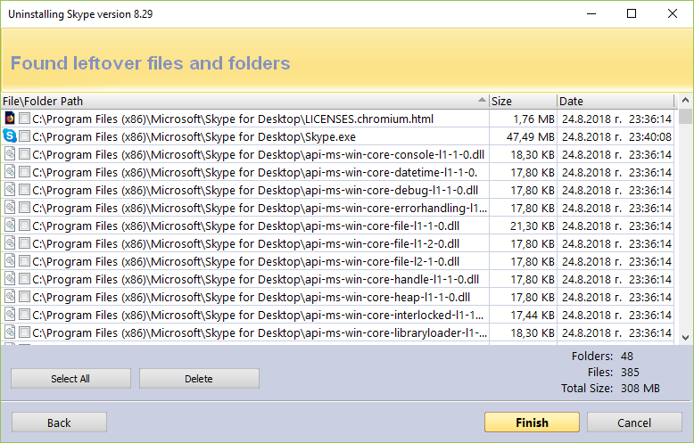

Revo Uninstaller Pro shows you found leftover files and folders so you can check the results, and delete the ones you want. Revo Uninstaller Pro also displays the number of files and folders found, as well as their total size on the drive.
In case you want to change the scanning mode, or you have not deleted all Registry items you can click the Back button, and return to the previous step.
Deleted files and folders are moved to the Recycle Bin by default, so you can recover them from there. You can change that option in Options -> All Programs.

You can bring up a context menu by right clicking on a file or folder:
Open – acts the same way as if you double clicked on the file or folder in Windows Explorer. Note that if there is no program associated with the file, nothing will happen.
Properties – acts the same way as if you right clicked on a file, and chose Properties – shows various properties like file size, attributes, date of creation, modification, etc.
Open Containing Folder – opens the folder that contains the selected item in Windows Explorer.
Export – exports the list of found leftover files and folders to an HTML file.

You can use the Select All button to select all found leftover files and folders at once, and then use the Delete button to delete them.

    - Quick Uninstall

Another way to uninstall a program, or a few programs at once, is to use the Quick Uninstall command. If you select only one program, the Quick Uninstall command will be available in the More Commands button. If you select multiple programs, the regular Uninstall button will switch to the Quick Uninstall button. The Quick Uninstall is similar to the normal uninstallation process in that it will open a window, and start the uninstallation of the selected program(s). The difference is that, if applicable, Quick Uninstall will try to run a silent uninstallation of the selected program. A successfully run a silent uninstallation would mean that you would not see any prompts or even a progress indicator of the built-in uninstaller. You would only see a notification after the built-in uninstaller has done its job.

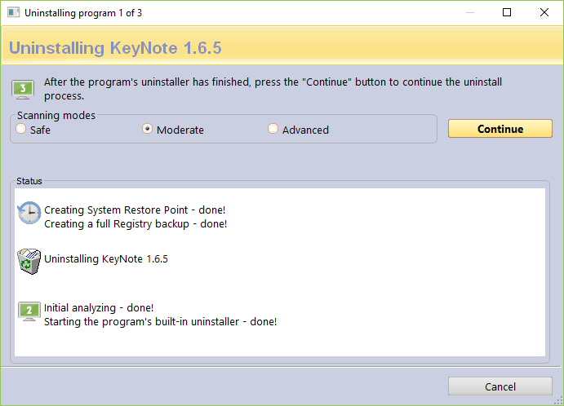

Another difference is that Quick Uninstall will not show any leftover lists. It will scan for leftovers as usual but instead of prompting the user to select which ones to delete, Revo Uninstaller Pro will delete them automatically. After the deletion, Revo Uninstaller Pro will continue with running the built-in uninstaller of the next selected program, if any. However, the full Registry backup and the System Restore Point are not performed again, as it is not necessary because they were done at the beginning.
Again, by default, all deleted Registry entries are backed up, and any deleted leftover files and folders are moved to the Recycle Bin.

  - Traced Programs

The Traced Programs module of the Uninstaller shows all installation logs traced with Revo Uninstaller Pro. To start the module, click its button in the Uninstaller group of modules in the lower part of the Commands Panel

To trace a program with Revo Uninstaller Pro you can right click on its installation (setup) file, and select Install with Revo Uninstaller Pro, or click the Install Program with Revo Uninstaller Pro button on the Commands Panel while All Programs or Traced Programs modules are opened. More details are available in section 3.4 of the user's guide.

Depending on the view setting, logs are shown as Icons, a List, and with Details such as Name, Size, Creation Date, Registry items, Files and Folders, Comment, and Import status.

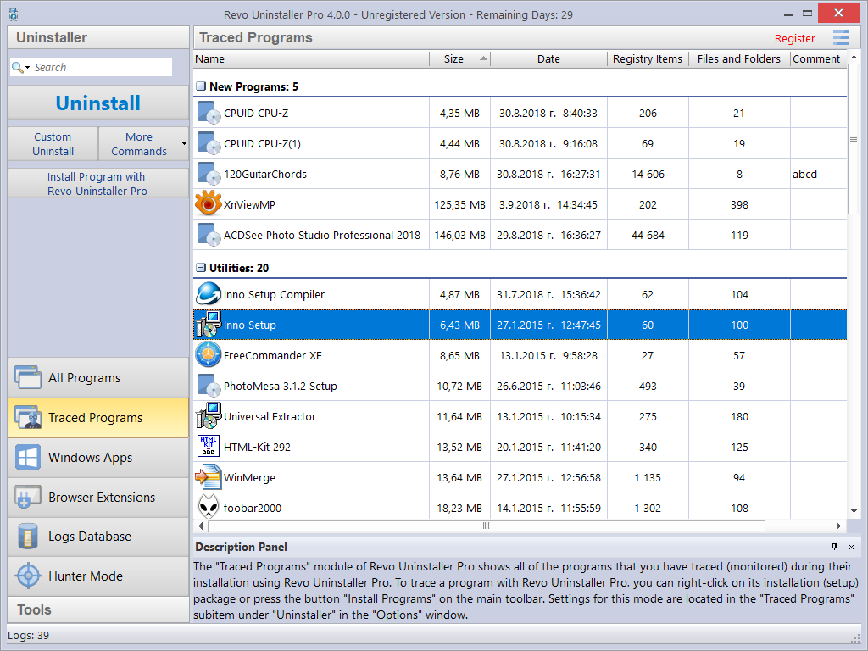

By default, created logs are shown in the Icons view mode, and when you select a log, below in the Description Panel you will see some of the properties of the selected log: Icon, Size, Date, Registry items, and Files and Folders. You may see similar information when you hover the mouse cursor over a log in the list. In that case, the information is shown as a tooltip, next to the mouse cursor.

Using the Search field in the upper right part of the Commands Panel, you can filter the program list by name, publisher, or comment. You can choose the search criteria from the drop-down menu shown after clicking the magnifying glass. The program list will be filtered in real-time as you type. When searching, the status bar will display the number of found programs that match the search criteria.

All logs are grouped in two default groups – New Programs and Other Programs. The total number of logs is shown in the status bar.
You can assign each program to a group by using the context menu when right clicking on a program. Removing a program from a group is also possible from the same context menu. The default groups are Internet, Games, Multimedia and Utilities. Additional groups can be added from the Groups Manager in the Options, or directly from the context menu: Add to Group -> Add new group.
The selected (right clicked) item will be automatically moved to the newly added group.

Some other commands available from the context menu are:
Export Log - exports the data of the log to a file for easy and convenient importing on another computer.
Delete Log - deletes the log from the list, including all data in the log, the installed program remains untouched.
Merge selected logs – combines the data of two or more selected logs into a single log.
Add/Edit Comment – opens a window to add a comment about the program, or edit an existing one. The comment is visible in Details view.
Change Icon – opens a window to select a new icon for the program displayed in the list. You can browse for an icon in any EXE or DLL file.
Rename Log - lets you change the name of the log in the list.
Edit Log - opens a window allowing you to change all data in the log. For more information, check section 3.2.4.
Remove from Group - Removes the selected log(s) from its current group.

Traced Programs settings are located in Options -> Traced Programs.

Available commands to work with the logs are…

    - Uninstall

Uninstallation of a logged program reverts all changes made to the system during its installation the way they were logged by Revo Uninstaller Pro. This process includes changes to the Windows Registry, files and folders.
After executing the command, uninstallation of Registry items, files, and folders begins, and you can see the progress.

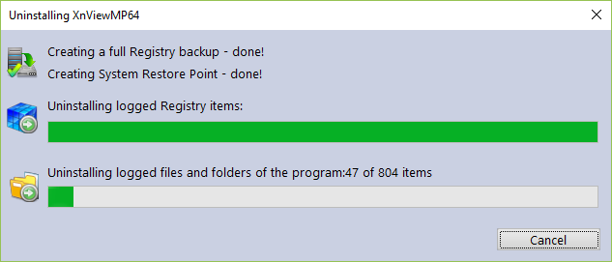

The window closes automatically when the uninstallation completes. By default, all changed Registry items are backed up. If you want to back up the removal of files and folders, you have to change the setting in Options -> Uninstaller.

    - Custom Uninstall

A Custom Uninstall of a logged program allows you to select which changes made to the system during the installation of said program you want to revert. After executing the command, the uninstallation wizard will start. The wizard may consist of one or two steps, depending on the items the log contains. A tree structure displays all logged (if any) Registry items in the first step of the uninstallation wizard. The wizard has two windows – the left one displays the Registry keys tree, and the right one displays the Registry values in the corresponding key. There are two counters in the lower part of the window; they show the numbers of logged keys and values.

The different colors and fonts provide more information about the items:
Bold item – logged by Revo Uninstaller Pro as created by the installed program.
Red item – the item is excluded from the uninstallation process (the list of excluded items is shown in Options -> Uninstaller -> Traced Programs -> the Registry tab).
Grayed item – the item does not exist in the system at the moment.

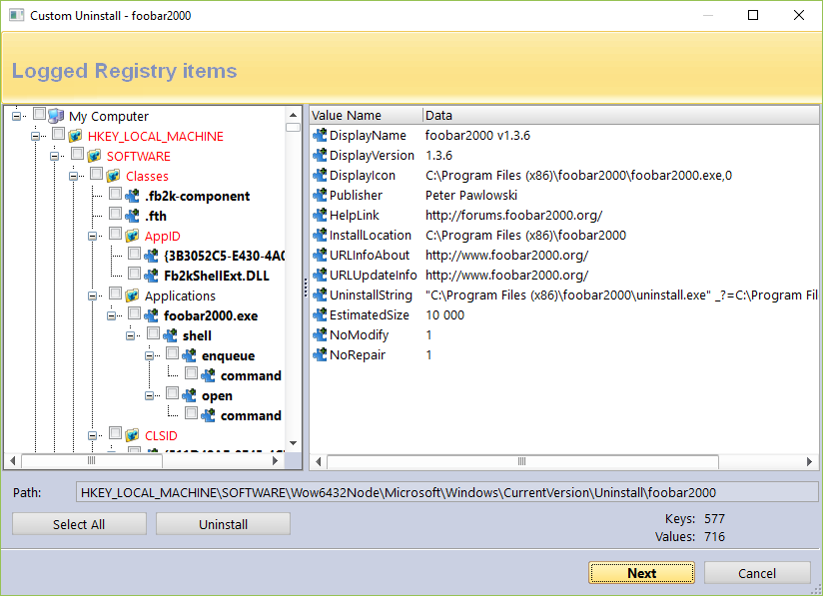

You have to check items that you want to uninstall. If you want to uninstall all of them, you can use the Select All button to check them all. However, regardless what items have check marks, only items that are both checked and in bold will be deleted.

To start the uninstallations, press the Uninstall button, and you will see the progress bar for the operation.

There are some commands available from the context menu of the tree:
Expand All – expands the entire tree so the whole hierarchy of keys is visible.
Collapse All – collapses the entire tree making “My Computer” the only visible item.
Export All – exports displayed leftover data to an HTML file.
Expand selected key – expands only the selected key making all its sub items visible.
Collapse selected key – collapses only the selected key making its sub items hidden.
Uninstall selected key – deletes the selected key even if the item does not have a check mark.
Mark selected key as Created – marks the selected key as if it was created by the program, so it will be removed during the uninstallation process. This feature is useful when you see a Registry key, which you are sure is created by the program but is not marked as created because of the safety algorithms in Revo Uninstaller Pro.

Warning: Be very careful using this command. Mark the key only if you are absolutely certain that it belongs to the uninstalled program!

Add to Exclude List – adds the selected key to the exclude list, which protects the key from deletion, and marks it in red. You can edit the exclude list from the Options in Revo Uninstaller Pro.
Open Registry Key… - opens the selected Registry key in the Windows Registry Editor (regedit.exe).

There are two commands available from the context menu of the list of values:
Uninstall selected values – deletes the selected value. To select multiple random values, you can hold down the Ctrl key on your keyboard while selecting them with your mouse. For multiple consecutive values hold down the Shift key.
Open Parent Registry key – opens the parent Registry key of the selected value in the Windows Registry Editor (regedit.exe).

If there are any logged files and folders, you can click the Next button to see the list. There are two counters in the lower part of the window; they show the numbers of logged files and folders. There is also an option to rename items that had existed with a certain name before the installation of the program, but were renamed during said installation: Execute Rename operations of previously existing on the system files and folders.

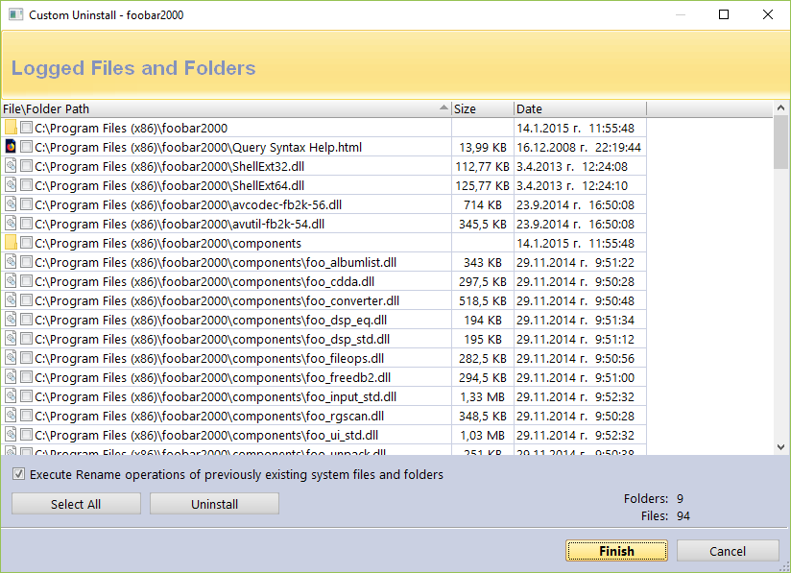

If you want to uninstall files and folders, you have to check them, or use the Select All button to check all existing items, and remove them by clicking the Uninstall button.

There are two commands available from the context menu of the list of files and folders:
Open – acts the same way as if you double clicked on the file or folder in Windows Explorer. Note that if there is no program associated with the file, nothing will happen.
Properties – acts the same way as if you right clicked on a file, and chose Properties – shows various properties like file size, attributes, date of creation, modification, etc.
Open Containing Folder – opens the folder that contains the selected item in Windows Explorer.

    - Advanced Uninstall

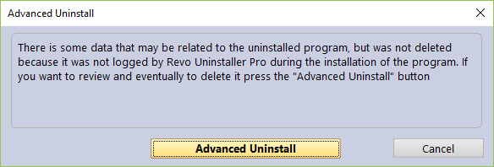

While the uninstallation of a traced program is in progress, Revo Uninstaller Pro may detect that there is some data related to the uninstalled program, which was not deleted because it was not logged by Revo Uninstaller Pro during the installation of the program. In that case, you will see a window with an Advanced Uninstall button. The Advanced Uninstall feature lets you review and delete the aforementioned data. If you want to review and possibly delete it, press the Advanced Uninstall button. This will start the Advanced Uninstall wizard, which may consist of two steps, one for the Registry leftovers, and one for the file and folder leftovers.

Warning: before deleting data using the Advanced Uninstall feature, be certain that it is related to or created by the uninstalled program.

If there are possibly related to the uninstalled program Registry items you will see the first step of the wizard - tree with Registry items you can uninstall. When you click on a key in the tree its values, if any, are shown in the list. The font property of items is used to give more information about the items. Such information is:
Bold item – logged by Revo Uninstaller Pro as created by the installed program.
Red item – the item is excluded from the uninstallation process (the list of excluded items is shown in Options -> Uninstaller -> Traced Programs -> the Registry tab).

You have to check items that you want to uninstall. If you want to uninstall all of them, you can use the Select All button to check them all. However, regardless what items have check marks, only items that are both checked and in bold will be deleted.

To start the uninstallations, press the Uninstall button, and you will see the progress bar for the operation.

There are some commands available from the context menu of the tree:
Expand All – expands the entire tree so the whole hierarchy of keys is visible.
Collapse All – collapses the entire tree making “My Computer” the only visible item.
Expand selected key – expands only the selected key making all its sub items visible.
Collapse selected key – collapses only the selected key making its sub items hidden.
Uninstall selected key – deletes the selected key even if the item does not have a check mark.
Mark selected key as Created – marks the selected key as if it was created by the program, so it will be removed during the uninstallation process. This feature is useful when you see a Registry key, which you are sure is created by the program but is not marked as created because of the safety algorithms in Revo Uninstaller Pro.

Warning: Be very careful using this command. Mark the key only if you are absolutely certain that it belongs to the uninstalled program!

Add to Exclude List – adds the selected key to the exclude list, which protects the key from deletion, and marks it in red. You can edit the exclude list from the Options in Revo Uninstaller Pro.
Open Registry Key… - opens the selected Registry key in the Windows Registry Editor (regedit.exe).

There are two commands available in the context menu of the list of values:
Uninstall selected values – deletes the selected value. To select multiple random values, you can hold down the Ctrl key on your keyboard while selecting them with your mouse. For multiple consecutive values hold down the Shift key.
Open Parent Registry key – opens the parent Registry key of the selected value in the Windows Registry Editor (regedit.exe).

If the Advanced Uninstall feature has detected additional leftover files and folders, click Next to see the list. There are two counters in the lower part of the window; they show the numbers of logged files and folders. If you want to uninstall files and folders, you have to check them, or use the Select All button to check all existing items, and remove them by clicking the Uninstall button.

There are two commands available from the context menu of the list of files and folders:
Open – acts the same way as if you double clicked on the file or folder in Windows Explorer. Note that if there is no program associated with the file, nothing will happen.
Properties – acts the same way as if you right clicked on a file, and chose Properties – shows various properties like file size, attributes, date of creation, modification, etc.
Open Containing Folder – opens the folder that contains the selected item in Windows Explorer.

    - Manage

The Manage menu (available when clicking the More Commands button) has the following commands…

Delete Log / Delete selected Logs – deletes the selected trace log(s) from the Revo Uninstaller Pro’s list and from the hard drive. This does not affect the installed program(s).
Merge selected logs – combines the logged data of the selected logs into a single log. The chronologically older(est) log is used as the main one, i.e. the data from the more recently created log(s) will be inserted into the older(est) log. After the merging process, you will be prompted to enter a name for the merged log. By default the name of the older(est) log is used but you can change it if you wish. The more recent log(s), whose data is merged, is/are deleted.
Rename Log - lets you change the name of the log in the list.
Edit Log - opens a window allowing you to change all data in the log. More information can be found a bit further down in the manual.
Import Log – opens a Windows Explorer dialog window allowing you to select .ruel files, which are exported trace logs by Revo Uninstaller Pro. After importing a log, it will appear in the Traced Programs module, alongside any other trace logs you may have created, and you can use the newly imported trace log as if you yourself have created it.
An alternative way to import an exported log file is to double click on it in your file manager, as Revo Uninstaller Pro should be associated with .ruel files. Revo Uninstaller Pro must be closed for the importing to work.
Export Log – allows you to export the created trace log into a .ruel so it can be imported later. For example, if you have problems uninstalling Program A, or just want to do a better uninstall of it, and a friend of yours has installed and traced the same program so he has a trace log. He can export the log, and send the .ruel file to you so you can import it, and use as if you had traced the program yourself.

The Edit Log window looks like this:

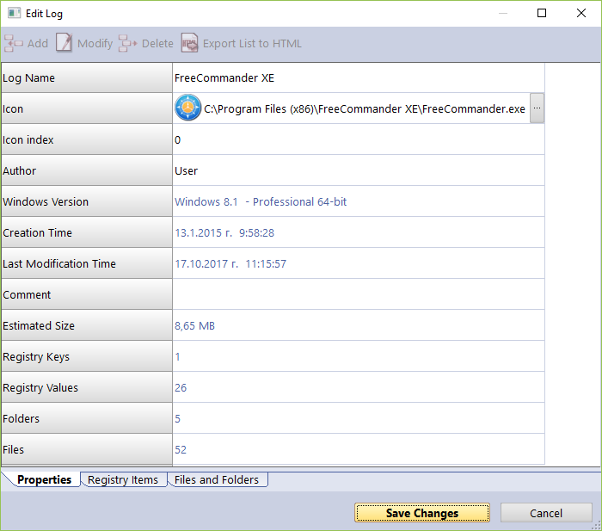

It contains three sections (tabs):
Properties – contains general information about the trace log: name, icon, the creator of the trace log, the version of Windows under which it was created, dates of creation and modification, number of logged Registry entries, files, and folders. From this tab, you can review and edit some common information of the log, user comment, etc. You can change the Name, Icon, Author, and Comment properties. Other listed fields are read-only, but their data will change if you make changes to the trace log.
Registry Items – here you can view and modify the logged Registry keys and values, contained within the trace log. A tree structure shows all logged (if any) Registry entries in a window divided into two parts – the left one shows all Registry keys in a tree-like structure, whereas the right one shows the corresponding value in a selected. The context menu commands and the meaning of the colored/bolded items in the tree and list is the same as described in the Custom Uninstall section (3.2.1). Modifications can be made using the commands using the toolbar at the top of the window. These are the commands:
Add Value/Key – allows you to manually add Registry keys and values to the trace log. To add a key or a value to the log, first you have to select a key from the tree that will be the parent of the newly added item.
Modify – allows you to modify the data of an existing Registry key or value. First select the entry, click Modify, and make the desired changes.
Delete – deletes the logged Registry key or value from the trace log file. This does not affect any data in the Registry of your operating system.
Export list to HTML - exports the data from the opened tab to an HTML file.

Files and Folders – here you can view and modify files and folders logged in the trace file. They are displayed in a simple list. The context menu commands and the meaning of the colored/bolded items in the tree and list is the same as described in the Custom Uninstall section (3.2.1). Modifications can be made using the commands using the toolbar at the top of the window. These are the commands:
Add File/Folder - allows you to manually add files and folders to the trace log. To add a file or folder, first you have to select a folder from the tree that will be the parent of the newly added item.
Modify - allows you to modify a few properties of a logged file or folder, namely whether they were created or renamed, and the name of said file or folder.
Delete - deletes the logged file or folder from the trace log file. This does not affect any data on your hard or SSD drive.
Export list to HTML - exports the data from the opened tab to an HTML file.

  - Windows Apps

The Windows Apps module lists all installed Windows apps, this includes built-in apps when you install Windows, and apps downloaded from Microsoft Store. The module helps you uninstall any app with a single click. To start the Windows Apps module click press its button in the lower part of the Commands Panel
The main window has a few columns with Name, Size, Install Date, Version, Publisher, and Description. Right clicking the header of a column allows you to change the alignment and choose which columns are shown. The entire list may be sorted by clicking a column header.

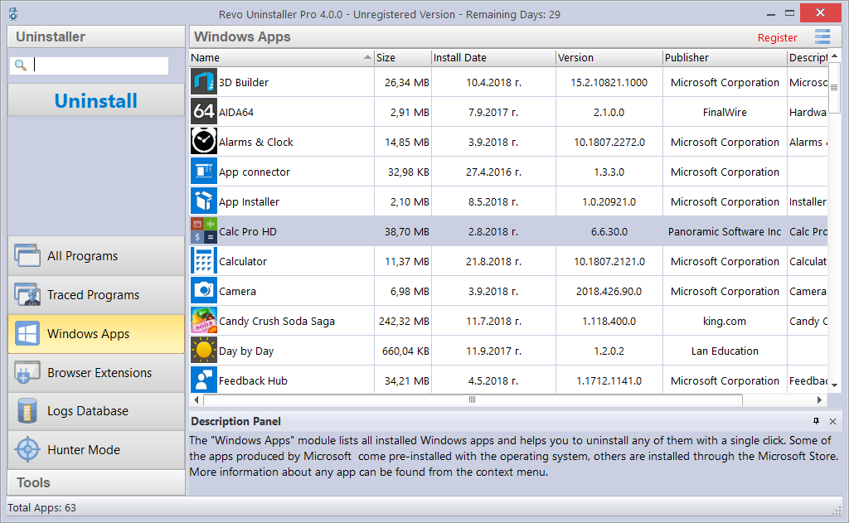

Using the Search field in the upper right part of the Commands Panel, you can filter the app list by name, publisher, or comment. The app list will be filtered in real-time as you type. When searching, the status bar will display the number of found programs that match the search criteria.

The main command is Uninstall - selecting an app and pressing the Uninstall button will bring up the Uninstall Wizard. Revo Uninstaller Pro tries to create a full Registry backup (if this is not disabled in the Options) and a System Restore Point, and then runs the default command to uninstall the app. After the app is uninstalled, you have to click the Scan button to continue the uninstallation process with Revo Uninstaller Pro.

Revo Uninstaller Pro shows found leftover Registry entries first. Registry keys and values found as created by the uninstalled program are in bold. Entries that are NOT in bold are considered as not created by the uninstalled program. You can safely check them (leave them checked), as they will not be deleted! Entries not in bold are displayed for two reasons: 1) for information: to give you a better idea of the tree structure, and 2) to make selecting leftovers for deletion easier and faster. You can simply check an entire parent branch, as that will automatically select all of its children. This eliminates the need to check each individual leftover item manually and separately. So, again, whatever items you check, when you press the Delete button, only entries that are checked and in bold will actually be deleted. This applies to when the Select All button is used as well.

Deleted Registry entries are backed up, so if you need them later you can restore them using the Backup Manager.

You can bring up a context menu by right clicking. These are the available commands:
Expand All – expands all items in the Registry tree – by default it is expanded so you should not see any difference the first time you use this command.
Collapse All – collapses all items in the Registry tree.
Export All – export shown leftover data to an HTML file.
Expand selected key – expands the selected key and its sub items.
Collapse selected key – collapses the selected key and its sub items.
Uninstall selected key – deletes the selected key from the system.
Mark selected key as Created – marks the selected key as created by the program you are uninstalling. This feature is useful when you see a Registry key, which you are sure is created by the program but is not marked as created because of the safety algorithms in Revo Uninstaller Pro.

Warning: Be very careful using this command. Mark the key only if you are absolutely certain that it belongs to the uninstalled program!

Add to Exclude List – adds the selected key to the exclude list, which protects the key from deletion, and marks it in red. You can edit the exclude list from the Options in Revo Uninstaller Pro.
Open Registry Key… - opens the selected Registry key in the Windows Registry Editor (regedit.exe).

After removing the Registry leftovers, you can click the Next button, and continue to the file and folder leftovers. Note that the Next button may not be available if there are no other leftovers found.

Revo Uninstaller Pro shows you found leftover files and folders so you can check the results, and delete the ones you want. Revo Uninstaller Pro also displays the number of files and folders found, as well as their total size on the drive.
In case you want to change the scanning mode, or you have not deleted all Registry items you can click the Back button, and return to the previous step.
Deleted files and folders are moved to the Recycle Bin by default, so you can recover them from there. You can change that option in Options -> All Programs.

You can bring up a context menu by right clicking on a file or folder:
Open – acts the same way as if you double clicked on the file or folder in Windows Explorer. Note that if there is no program associated with the file, nothing will happen.
Properties – acts the same way as if you right clicked on a file, and chose Properties – shows various properties like file size, attributes, date of creation, modification, etc.
Open Containing Folder – opens the folder that contains the selected item in Windows Explorer.
Export – exports the list of found leftover files and folders to an HTML file.

You can use the Select All button to select all found leftover files and folders at once, and then use the Delete button to delete them.

Other commands available in the context menu for Windows Apps are:
Search at Google for – use it to search online using Google for the application’s name or publisher. This will open your default web browser and display the results of the search.
Install Location – opens the location where the app is currently installed in Windows Explorer.
Open Registry Key – opens the Registry editor (regedit.exe) and displays the Registry key containing the uninstallation information for the selected application.
Refresh – reloads the Windows Apps list.

  - Browser Extensions

The Browser Extensions module lists and helps you delete different kinds of additional components (called extensions or add-ons), which popular browsers let you install for additional customization. Browser extensions are shown in groups, based on the browser. Currently, supported are: Google Chrome, Mozilla Firefox, Microsoft Internet Explorer, and Microsoft Edge. To start it click its in the lower part of the Commands Panel.

The main window has columns containing the Name, Type, Version, Publisher, and Description. The Type column shows you what kind of an extension is, according to the browser. Right clicking the header of a column allows you to change the alignment and choose which columns are shown. The entire list may be sorted by clicking a column header.

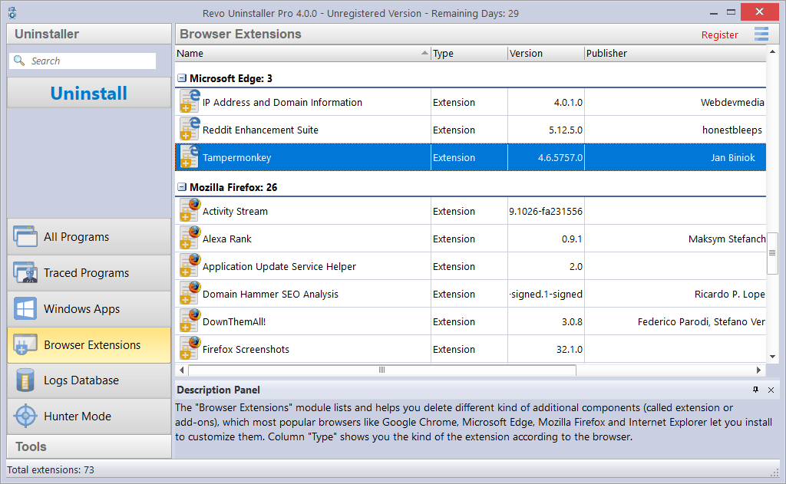

Using the Search field in the upper right part of the Commands Panel, you can filter the browser extension list by name, publisher, or description. The browser extension list will be filtered in real-time as you type. When searching, the status bar will display the number of found programs that match the search criteria.

For Microsoft Edge extension the main command is Uninstall, whereas for the other browsers it is. Selecting a Microsoft Edge extension and pressing the Uninstall button starts a Windows App uninstallation process because all Edge extensions are installed as apps. For details of the process, see section 3.3. Selecting an extension of another browser and pressing the Remove button starts the extension removal process.

Other commands available from the context menu for Browser Extensions are:
Search at Google for – use it to search online using Google for the extebnsion’s name or author. This will open your default web browser and display the results of the search.
Refresh – reloads the Browser Extensions list.

  - Logs Database

This is a database of logs of traced programs through the monitoring module of Revo Uninstaller Pro. The Logs Database is created and maintained by Revo Uninstaller Pro's team. The logs are stored on our web server, and you can use them to uninstall programs or to remove leftovers of previously uninstalled program. To start it press its button in the lower part of the Commands Panel.

Using a log from the Logs Database is the same as if you have made the log and traced the program yourself. Therefore, even installing Revo Uninstaller Pro on a computer that already has many installed programs that you had not traced, you can still take advantage of the possibility for better and complete uninstallation using the logs from the Logs Database, as you only have to search for the program you want to uninstall, and select click Uninstall.

When you open the Logs Database, by default you will see a list of logs compatible with your version of Windows. The number on the left side of the status bar indicates how many programs are listed based on the current filter settings and any search terms entered. The number on the right side of the status bar indicates the total number of logs in the Logs Database. The database is updated automatically; however, you can change this behavior in the Options.

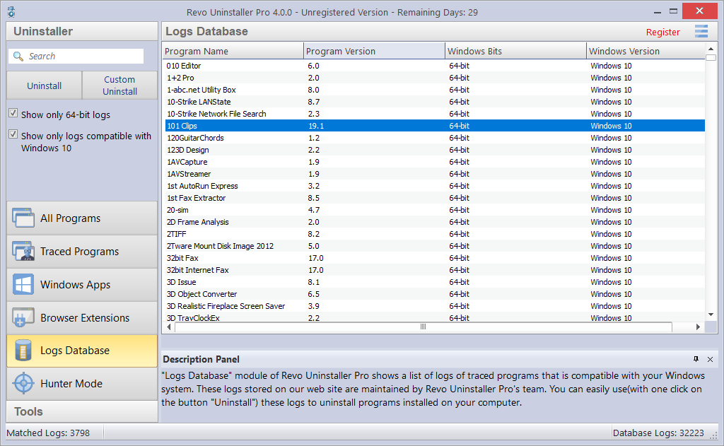

Using the Search field in the upper right part of the Commands Panel, you can filter the log list by name. The log list will be filtered in real-time as you type. When searching, the status bar will display the number of found programs that match the search criteria.

Under the Search field, there are two additional options:
Show only XX-bit logs - where XX-bit is 32-bit or 64-bit, depending on the architecture of your Windows version. When checked, you will only see logs for the corresponding architecture as yours (32-bit or 64-bit). Disabling the option will show logs for both architectures.
Show only logs compatible with [your Windows version] - when checked, you will only see logs that are made for the same version of Windows as the one you are using. Disabling the option will show logs for all versions of Windows from Windows XP to Windows 10.

In the Logs Database you have only two commands - Uninstall and Custom Uninstall. After you select a program from the list, and click either command, the selected log is downloaded from our website, imported to your own logs, and then the chosen command is executed, as if it is your own log:
Uninstall - uninstalls the program you have selected from the list using the log from the Logs Database; Revo Uninstaller Pro applies all changes recorded in the log.
Custom Uninstall – presents you with a wizard with all traced items (first Registry entries in step 1, and then Files and Folders in step 2, and allows you to select the items you want to uninstall.
The procedure is the same as the Custom Uninstall command for Traced Programs, so you can check section 3.2.2 for more information.

For smaller programs, you may use a log for any Windows version in order to uninstall them properly. Therefore, if the program you are searching for is not listed for your specific Windows version, you may try to remove the check mark for the option Show only logs compatible with [your Windows version], and see if the program will appear in the filtered list.

  - Forced Uninstall

Revo Uninstaller Pro has a very powerful feature called Forced Uninstall. To start it, you must have opened either the All Programs or the Traced Programs module, and click the Forced Uninstall button on the left side. This feature helps you locate and remove leftovers of programs that had been uninstalled previously (before Revo Uninstaller Pro was installed on the computer), or have been incompletely installed or uninstalled, and there are still remnants of on your computer. It does not matter if the program you want to remove is listed in Revo Uninstaller Pro or in the "Programs and Features" and “Apps and features” applets. Forced Uninstall gives power to the user while maintaining the safe and accurate results.
Forced Uninstall requires at least one of two parameters to get the job done: 1) the exact name and/or 2) the full path to the program you want to remove. It is important for the name to be as exact as possible, because Revo Uninstaller Pro searches your entire system, and may falsely detect leftovers if you enter an incomplete or inaccurate name. For example, if you want to remove Microsoft Office Enterprise 2007 you have to enter Microsoft Office Enterprise 2007, and not: Office, MS Office, Microsoft! If for some specific purposes you need to enter more than one name here, you can do that, separating names with a semicolon (;). The second parameter is a path to the main folder of the program and/or to the main executable file (.exe). You can enter the path manually, or you can use the Browse button to locate a file or a folder related to or created by the program you want to uninstall. You can enter multiple paths.

Using the Browse button to locate the program’s executable file (.exe) or main installation folder is recommended.

If you want to remove any remnants of a previously uninstalled program, a very efficient way to do that would be to enter the full path to the program’s installation location, if it still exists on the computer.
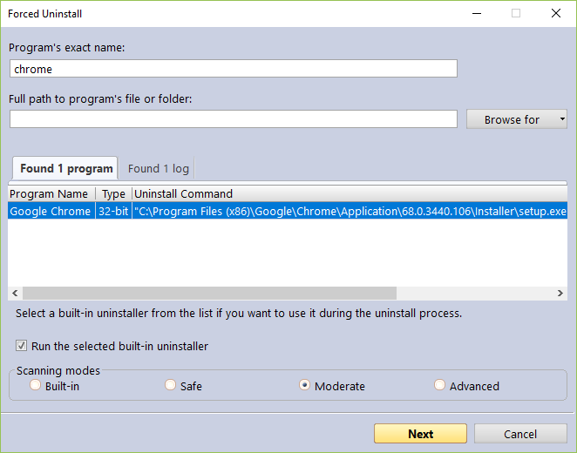

After you enter either of the initial parameters, Forced Uninstall will trigger a search for a built-in uninstaller and any trace logs of the program you want to uninstall. Revo Uninstaller searches for logs based on the entered name among the logs you have in the Traced Programs, as well as the logs in the Logs Database module. If both built-in uninstallers and logs are found, the results are shown in two tabs - Found xx programs and Found xx logs
If there is a built-in uninstaller or several possible uninstallers found, Revo Uninstaller Pro lists them in the same window, so you can choose to run one of them.

If there is at least one log found based on the name you have entered, it is listed with the following information:
Name - name of the log, usually the name of the program.
Program Version - if the log is from the Logs Database, you will see its version, which can help you decide if it is appropriate for your case.
Windows Version – the version of Windows, on which the log is made; also to help you to decide if it is appropriate for you to use the log.
Source - whether the log was found among your local logs in Traced Programs, or in the Logs Database module.

If you want to run the built-in uninstaller before scanning for leftovers, just select the option Run selected built-in uninstaller checked, and click Next. Revo Uninstaller Pro will try to run the built-in uninstaller as usual, and after it finishes, you will have to click the Scan button to continue the uninstallation process with Revo Uninstaller Pro by scanning for leftovers. Note that the built-in uninstaller may show up behind other open windows so you may need to cycle between them by using the Alt+Tab key combination – hold the Alt key and press the Tab key.

If you decide to use a log in the uninstallation process, you must select it, and make sure the Use selected log option beneath the list of found logs, is checked, and then click the Next button. That will open a window where Revo Uninstaller Pro first creates a full Registry backup and a System Restore Point (unless their creation is disabled in Options -> Uninstaller), and then loads selected log data, showing the Registry entries in the first step, and the files and folders in the second one.

If neither the built-in uninstaller nor a log is used, clicking the Next button will still proceed to create a full Registry backup and a System Restore Point (unless their creation is disabled in Options -> Uninstaller), but after that it will initiate a regular leftover scan instead.

Note: for Revo Uninstaller Pro to be able to use a trace log from our Logs Database, an Internet connection is required.

Revo Uninstaller Pro shows found leftover Registry entries first. Registry keys and values found as created by the uninstalled program are in bold. Entries that are NOT in bold are considered as not created by the uninstalled program. You can safely check them (leave them checked), as they will not be deleted! Entries not in bold are displayed for two reasons: 1) for information: to give you a better idea of the tree structure, and 2) to make selecting leftovers for deletion easier and faster. You can simply check an entire parent branch, as that will automatically select all of its children. This eliminates the need to check each individual leftover item manually and separately. So, again, whatever items you check, when you press the Delete button, only entries that are checked and in bold will actually be deleted. This applies to when the Select All button is used as well.

Deleted Registry entries are backed up, so if you need them later you can restore them using the Backup Manager.

You can bring up a context menu by right clicking. These are the available commands:
Expand All – expands all items in the Registry tree – by default it is expanded so you should not see any difference the first time you use this command.
Collapse All – collapses all items in the Registry tree.
Export All – export shown leftover data to an HTML file.
Expand selected key – expands the selected key and its sub items.
Collapse selected key – collapses the selected key and its sub items.
Uninstall selected key – deletes the selected key from the system.
Mark selected key as Created – marks the selected key as created by the program you are uninstalling. This feature is useful when you see a Registry key, which you are sure is created by the program but is not marked as created because of the safety algorithms in Revo Uninstaller Pro.

Warning: Be very careful using this command. Mark the key only if you are absolutely certain that it belongs to the uninstalled program!

Add to Exclude List – adds the selected key to the exclude list, which protects the key from deletion, and marks it in red. You can edit the exclude list from the Options in Revo Uninstaller Pro.
Open Registry Key… - opens the selected Registry key in the Windows Registry Editor (regedit.exe).

After removing the Registry leftovers, you can click the Next button, and continue to the file and folder leftovers. Note that the Next button may not be available if there are no other leftovers found.

Revo Uninstaller Pro shows you found leftover files and folders so you can check the results, and delete the ones you want. Revo Uninstaller Pro also displays the number of files and folders found, as well as their total size on the drive.
In case you want to change the scanning mode, or you have not deleted all Registry items you can click the Back button, and return to the previous step.
Deleted files and folders are moved to the Recycle Bin by default, so you can recover them from there. You can change that option in Options -> All Programs.

You can bring up a context menu by right clicking on a file or folder:
Open – acts the same way as if you double clicked on the file or folder in Windows Explorer. Note that if there is no program associated with the file, nothing will happen.
Properties – acts the same way as if you right clicked on a file, and chose Properties – shows various properties like file size, attributes, date of creation, modification, etc.
Open Containing Folder – opens the folder that contains the selected item in Windows Explorer.
Export – exports the list of found leftover files and folders to an HTML file.

You can use the Select All button to select all found leftover files and folders at once, and then use the Delete button to delete them.

  - Install Programs

Revo Uninstaller Pro has a feature that allows monitoring program installations, and detecting system changes. The process is done in real-time – while the program is being installed.

This feature is also very powerful, because by monitoring system changes during the installation, we eliminate the necessity of all scanning algorithms applied during the uninstallation. You can use the installation log for a complete removal of the program, just as if it had never been installed at all.



With this feature, we monitor system changes and we are sure that the changes are made by the installed program.

IMPORTANT: There is a restriction for using this feature - you should not install two or more programs at the same time, or run/start other programs during the installation. In order for the trace log to be as clean and accurate as possible, each traced program needs to be installed separately. You do not need to stop all already running programs, but you need to not run any new programs or program installations.

You can use the Custom Uninstall mode on Traced Programs, which allows you to mark and uninstall the items you want, so even if by mistake you have started another program or setup, you can still customize the uninstallation of the traced program. Still, it is recommended that you avoid the need for this altogether.
The tracing feature has one more advantage – because it works in real time, it does not incur almost any additional time to the time required for the actual program installation. Beginning a trace takes only a few seconds.

To install programs through Revo Uninstaller Pro you have two options:
- Use the Install Program with Revo Uninstaller Pro button in the All Programs or Traced Programs modules. Start Revo Uninstaller Pro, click the Install Program with Revo Uninstaller Pro, then browse for the setup file of the program you want to monitor.
- Right-mouse click on the setup file of the program you want to monitor, and select Install with Revo Uninstaller Pro.
In either case, the program installation will start, and you will need to complete it as usual.

When an installation process is started through Revo Uninstaller Pro, a toolbar will appear at the top of your screen. The installation process will continue in the usual way, and Revo Uninstaller Pro will monitor system changes during the installation. You can switch the wide toolbar at the top of the screen with a smaller one from the Options -> Traced Programs -> Trace programs in compact mode.

After the program has finished installing, we recommend that you to run it (if there are several components to the program, run them all), make any desired changes to its settings, then close it. That way Revo Uninstaller Pro will log the configuration settings and when you uninstall that program, it will remove these settings as well.

After closing the installed program, click the Stop button on the Revo Uninstaller Pro’s trace bar. Revo Uninstaller Pro will suggest a name for the log. That name will be listed in the Traced Programs tab in the uninstaller. Enter whatever name you wish, or leave it as is, and click the Save button.

Here is a summary of the steps needed to install programs with Revo Uninstaller Pro:

- Click the Install Program with Revo Uninstaller Pro button in the All Programs or Traced Programs tab, then browse for the program you want to install, or right click the program, and select Install with Revo Uninstaller Pro.
- Install the program as usual.
- Start and configure the program(s).
- Press Stop and Save buttons on Revo Uninstaller Pro trace bar.

Some programs require rebooting the computer before you are able to run them for the first time. In that case, you will have to stop monitoring, save the log, and reboot. Revo Uninstaller Pro has the ability to detect system reboots, and save the log automatically, although in such a case the name of the log will be set by Revo Uninstaller Pro.

  - Hunter Mode


Hunter mode is an innovative and flexible feature of Revo Uninstaller Pro, which gives you the ability to uninstall, stop, or delete simply by pointing to application icons on the Desktop or system tray, or opened application windows. This can be very useful because many applications loading on start-up and/or remain in the system tray without your consent, or you do not even know which application that is.

To start it click the Hunter mode button in the lower part of the Commands Panel. When you click the button, the Revo Uninstaller Pro’s window will disappear, and a small blue target icon with a crosshair will appear at the upper right corner of your screen. Hunter mode is now activated.

Right clicking the target icon brings a context menu with the following options:
Open main window – exits Hunter mode, and re-opens Revo Uninstaller Pro’s main window.
Auto Start with Windows – sets Hunter Mode to start automatically with Windows.
Window's size – allows you to change the size of the target icon to small, medium or large.
Transparency – allows you to set the level of transparency of the target icon (default is 50%).
Help – opens Revo Uninstaller Pro’s help file.
EXIT – closes Revo Uninstaller Pro entirely.

To operate in Hunter mode you simply need to drag and drop the target icon over the icon or window of the program you want to manage.

Here is a more detailed description:
1. Press and hold the left mouse button over the target icon.
2. Move the target icon with the mouse over an item supported by the Hunter mode (a Desktop shortcut, an icon in the system tray, opened window, etc.). While doing so, a tooltip is shown with information about the application you would select if you released the button.
3. After moving the icon over the desired item, release the left mouse button and a menu will appear.
4. Select a desired command from that menu:
Uninstall – starts the Forced Uninstall module of Revo Uninstaller Pro.
Stop Auto Starting – disables the application from automatically starting with Windows.
Kill – forcibly stops/closes the application.
Kill and Delete – forcibly stops, and deletes the application.
Open Containing Folder – opens the folder containing the selected program in Windows Explorer.
Search at Google for - use it to search online using Google for the program’s name or publisher. This will open your default web browser and display the results of the search.
Properties - show the application executable file's properties.
Cancel – cancels the operation.

- Backup Manager

Backup Manager helps you manage backup data stored by Revo Uninstaller Pro after deleting leftover Registry entries and files and folders (for the latter, if the necessary options are set). When restoring backed up items, you can restore all of the deleted data, or you can select which individual items you need recovered. If you need to free up disk space, you can any and all backed up data. To start the Backup Manager click its button in the Tools group in the lower part of the Commands Panel.

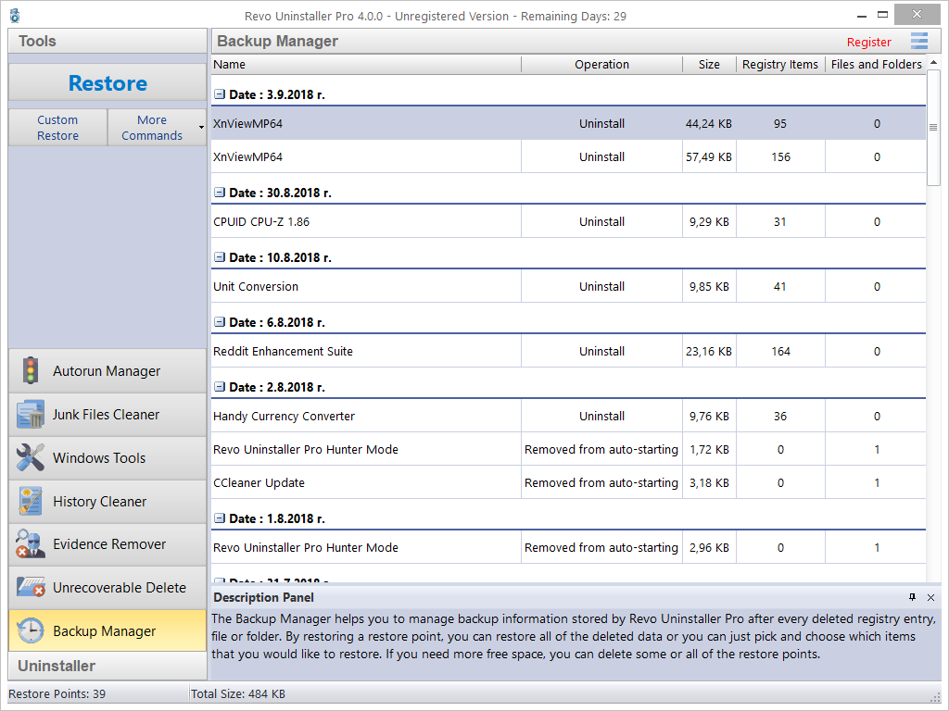

Every Registry entry that is deleted by Revo Uninstaller as being a leftover (by using the regular uninstaller, Advanced Uninstall for Traced Programs, Forced Uninstall, or Autorun Manager) is backed up by the Backup Manager. Files and folders by default are not, as files can be quite large in size so keeping backups of them isn’t always practical. However, you can change this behavior in the Options -> Uninstaller -> Delete files and folders to to Backup folder.

The main window of the Backup Manager shows you all locally stored backups, which are grouped by their date of creation, and sorted by time of creation. Each backup has the following properties: the operation during which the item was backed up, the size of the backup, and the number of items.

The following commands are available:
Restore – restores all backed up items; there is a progress bar, and when the restoration completes, the window closes automatically.
Custom Restore – allows you selectively restore only specific Registry entries, files and/or folders. This is done in one or two steps, depending on whether files and folders are also backed up by the Backup Manager. In the first step you will be able to restore Registry entries, and in the second one – files and/or folders (if any). Simply check the items you want to restore, and click the Restore button. You can also click the Select All button, and click Restore.
Delete – removes the selected backup, and moves it to the Recycle Bin.
Delete by Time – opens a window that allows you to delete multiple backups, based on their creation date; you can delete all backups in a specified period of time, or all backups before a specified date.
Delete All – removes all backups from the list, and moves them to the Recycle Bin.
Since all backups are deleted to the Recycle Bin, if you want to free up disk space, you will need to empty the Recycle Bin.

- Tools

Revo Uninstaller Pro gives you eight handy and powerful tools to clean up and maintain your system. You can access them by clicking the Tools button in the lower part of the Commands Panel.
  - Autorun Manager

The Autorun Manager gives you control over the startup process of your operating system by allowing you to select which processes, services, and scheduled tasks are allowed to start with Windows. With this tool, you can not only enable or disable applications from automatically starting, but also get more information about them, like publisher, description, launch path, and whether it is currently running. If this information is not enough to decide whether to enable or disable the program, you can get more information about the publisher and the executable file name directly from Google with only a couple of clicks.

When you buy a brand new computer, it has no or few applications, which are set to start with Windows. As you keep installing new software, some of it will set itself to start with your computer. You can see some of them in the system tray (the area in the Taskbar near the clock) as small icons. Often such applications are messengers, adware, optimizers, and other applications you do not need to start automatically.
When an application is started, it takes resources such as memory (RAM), CPU time, etc. The amount of these resources depends on the started application, but no matter how much resources it takes, it adds up as you run more and more programs.
If you want a program to start automatically with Windows, a common place to put it is in the Startup folder of the Start Menu.

Some applications like antivirus, firewalls, ant other and system programs must be started on Windows startup to keep your system running smoothly. Get as much information for an auto-starting program as possible, and decide whether to enable or disable it.

You can right click on a column header and choose which columns to show or hide some of the columns. That way you can also choose what to print.
Using the Search field in the upper right part of the Commands Panel, you can filter the browser extension list by name, launch path, or publisher. The program list will be filtered in real-time as you type. When searching, the status bar will display the number of found programs that match the search criteria.

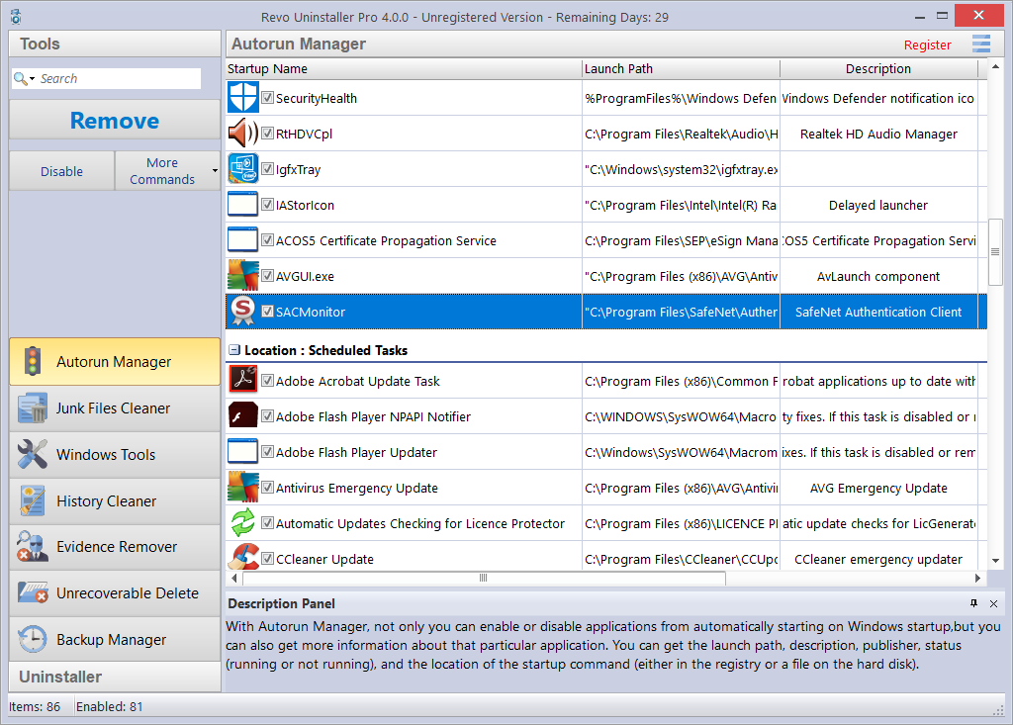

The most common task you would need to do is to Enable or Disable an application from auto starting with Windows. This can be done with a single click; all you have to do is to uncheck/check the check the box in front of the application name.

Another option is to Remove a program. This will not only disable it but also remove it from the list. Generally, it is recommended that you first simply Disable a program by unchecking it, as it is easily reversible – checking it again. Remove a program only if you are certain it will not have negative consequences.

There are several commands that you can access from the More commands:
Run process – starts the selected program/process if it is not RUNNING.
Kill process – forcibly stops a program if it is RUNNING.
Export List to – allows you to export the autorun list to TXT, HTML, or XLS (Microsoft Excel spreadsheet). You can choose which details/columns to include in the exported file.
NOTE: To export to an XLS file, you must have Microsoft Excel installed and working properly.
Print – allows you to print the autorun list.
Add – allows you to manually add a program for automatic startup with the operating system.
Name – the name of program, which will appear in the Autorun Manager.
Command (full path) – full path to the program you want to run automatically. You can also add parameters for the executable, but if you do so, put the path in quotations marks. For example:
“C:\Program Files\VS Revo Group\Revo Uninstaller Pro\RevoUninPro.exe” /hunter

Set auto start for:
All users – if you want that program to start when any user logs in.
Current user – if you want that program to start when only when the current user logs in.
Select to auto-start from:
Registry: Run – on every startup of Windows – this option will add a startup entry to the Windows Registry, which is a very common location for automatic startups.
Registry: RunOnce – only once on the next startup of Windows – also adds a startup entry in the Windows Registry, but it will start the program only once, after which the startup value in the Registry is deleted automatically by Windows.
Startup Folder – on every startup of Windows – this option will add a shortcut to the program in the Startup folder, which is also a common location for startups, and is accessible from Windows Explorer: C:\Users\[YOURPROFILE]\AppData\Roaming\Microsoft\Windows\Start Menu\Programs\Startup\.
Note: the AppData folder is hidden so you may need to show the hidden files and folders.
Refresh – reload the autorun list.

You can also bring up a context menu for an item if you right click. These are the available commands:
Run Process - starts the selected program/process if it is not RUNNING.
Kill Process - forcibly stops a program if it is RUNNING.
Search at Google for - use it to search online using Google for the autorun item’s name, file name, publisher, or description. This will open your default web browser and display the results of the search.
Open containing folder - opens the folder containing the selected item in Windows Explorer.
Goto Location – opens the location of the autorun entry, which can be a Registry entry, a shortcut in the Startup folder, etc.
Copy Launch Path – copies the launch path to the Windows clipboard so you can paste it in a text file, e-mail, chat message, etc.
Remove selected – removes the selected autorun item; the same as selecting it, and clicking the Remove button, as described above.
Remove all invalid – removes all autorun items that are detected as invalid, i.e. there is an autorun entry but it does not seem to point to an existing process or program.
Remove all disabled – remove all autorun items that are currently disabled (unchecked).
Properties – shows the file’s properties in Windows Explorer.
Open Windows Services – starts the Windows Services manager (services.msc) for more in-depth control over the services.

  - Junk Files Cleaner

The Junk Files Cleaner allows you to find and remove various types of junk and unnecessary files from your computer. Many Windows applications create junk files. Normally, such files are deleted by the application that had created them as soon they become unnecessary. However, sometimes they can remain on your hard drive if the program that created them was terminated unexpectedly, or it was not programed to delete said files, or there was a system crash, etc. The accumulation of such files takes up disk space, and may also sometimes impact system performance.

With the Junk Files Cleaner you can select which of your drives to scan, and what extension of files to scan for. The most common temporary and junk files extensions are built-in, but you can also add whatever extensions you want. It is also possible to manually add a specific folders (in the Options -> Junk Files Cleaner -> Include), whose content will be considered junk and will be emptied at every scan.
If you do not want to scan a whole drive, you can select only a particular folder. To do that, use the Scan Folder... button/text, just above the list of drives, and as soon as you select a folder, the scanning will begin.

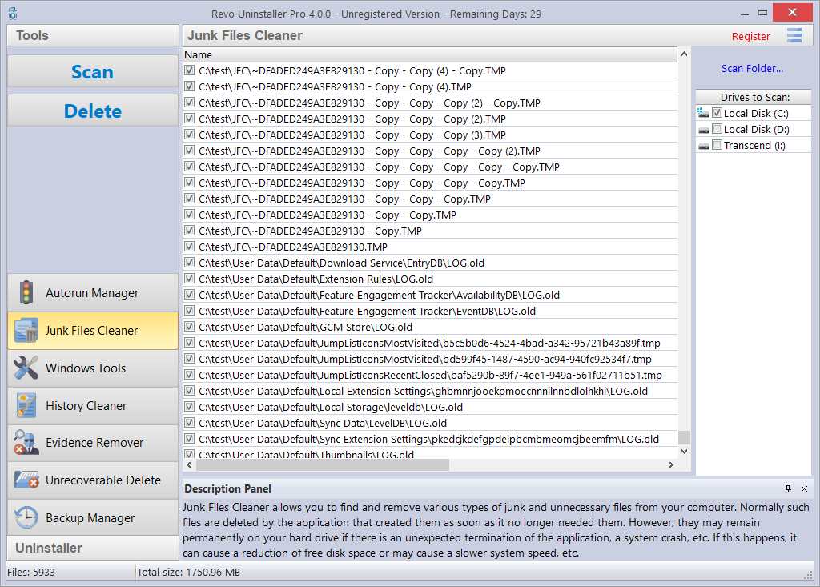

Available commands for the Junk Files Cleaner:
Scan –performs a scan with your current settings. A small window will appear while the scanning is in progress. You can cancel the scan by clicking the Cancel button, and you will be presented with a list of files found up until that point.
Delete – deletes all found junk files that have a checkmark, after the scan is completed or canceled.
Right clicking a junk file will bring up a context menu with the following commands:
Open – opens the selected file, as if you have double clicked it.
Search at Google for – use it to search online using Google for name of the selected file. This will open your default web browser and display the results of the search.
Open containing folder - opens the folder containing the selected item in Windows Explorer.
Properties – shows the file’s properties in Windows Explorer.
Check all items – puts a checkmark for all files in the list.
Uncheck all items –removes the checkmarks for all files in the list.
Check all selected items - puts a checkmark for all selected files in the list.
Uncheck all selected items - removes the checkmarks for all selected files in the list.

  - Windows Tools

There are many handy and useful tools and components bundled with every Windows operating system. Some of them have complex command line options; others are difficult to access. The Windows Tools section in Revo Uninstaller Pro gives you a fast – one-click access to more than ten Windows tools, which you can use in your daily routine. Some tools depend on the which version of Windows you are running.

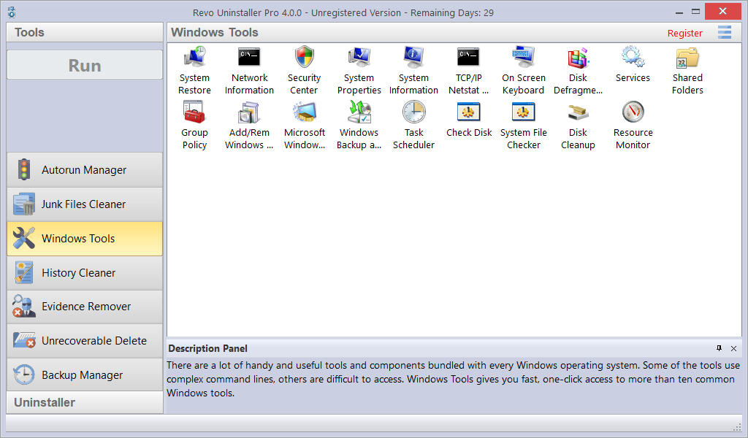

 | Windows  Windows Tools | Vista |  | 7 |  | 8 (Pro) |  | 8.1 |  | 10 |  |  |  | Server 2012 R2
№ | Windows  Windows Tools | x86 | x64 | x86 | x64 | x86 | x64 | x86 | x64 | x86 | x64 |  | x64
1 | System Restore | √ | √ | √ | √ | √ | √ | √ | √ | √ | √
2 | Network Diagnostics
3 | Network Information | √ | √ | √ | √ | √ | √ | √ | √ | √ | √ |  | √
4 | Security Center | √ | √ | √ | √ | √ | √ | √ | √ | √ | √
5 | System Properties | √ | √ | √ | √ | √ | √ | √ | √ | √ | √ |  | √
6 | System Information | √ | √ | √ | √ | √ | √ | √ | √ | √ | √ |  | √
7 | TCP/IP Netstat Command | √ | √ | √ | √ | √ | √ | √ | √ | √ |  | √ |  | √
8 | On-Screen Keyboard | √ | √ | √ | √ | √ | √ | √ | √ | √ |  | √ |  | √
9 | Disk Defragmenter | √ | √ | √ | √ | √ | √ | √ | √ | √ |  | √ |  | √
10 | Services | √ | √ | √ | √ | √ | √ | √ | √ | √ |  | √ |  | √
11 | Shared Folders | √ | √ | √ | √ | √ | √ | √ | √ | √ |  | √ |  | √
12 | Group Policy | √ | √ | √ | √ | √ | √ | √ | √ (Pro) | √ |  | √ |  | √
13 | Add/Remove Windows Components | √ | √ | √ | √ | √ | √ | √ | √ | √ |  | √
14 | Microsoft Windows Malicious Software Removal Tool | √ | √ | √ | √ |  | √ |  | √ | √ |  | √ |  | √
15 | Windows Backup and Restore | √ | √ | √ | √ | √ | √ | √ | √ | √ |  | √
16 | Task Scheduler | √ | √ | √ | √ | √ | √ | √ | √ | √ |  | √ |  | √
17 | Check Disk | √ | √ | √ | √ | √ | √ | √ | √ | √ |  | √ |  | √
18 | System File Checker | √ | √ | √ | √ | √ | √ | √ | √ | √ |  | √ |  | √
19 | Disk Cleanup | √ | √ | √ | √ | √ | √ | √ | √ | √ |  | √ |  | √
20 | Resource Monitor | √ | √ | √ | √ | √ | √ | √ | √ | √ |  | √ |  | √

    - System Restore

System Restore can be used to restore your computer to a previous state if a problem occurs, without losing your personal data files (such as Microsoft Word documents, browsing history, drawings, favorites, e-mails, etc.). System Restore creates snapshots of the most vital areas of the system, called Restore Points. These Restore Points allow you to revert the system back to a specific state. They are created daily and at significant system events (such as when an application or driver is installed, when Windows updates are installed, etc.). You can also create Restore Points manually.

    - Network Diagnostics

Network Diagnostics is used to gather and display information about your computer’s hardware, operating system, Internet configuration and network, etc. With the Network Diagnostics tool, you can perform a scan of your system, test network connectivity, and whether or not your network-related programs and services are functional. The information it gathers can be helpful when given to a support person trying to troubleshoot an issue you are having. This tool is available only on Windows XP.

    - Network Information

Network Information is used to display all current TCP/IP network configuration values, refresh Dynamic Host Configuration Protocol (DHCP) and Domain Name System (DNS) settings, Displays the full TCP/IP configuration for all adapters including IP address, MAC address, subnet mask, default gateway, Windows Internet Naming Service (WINS) and DNS configuration. Adapters can represent physical interfaces, such as installed network adapters, or logical interfaces, such as dial-up connections.

    - Security Center

Security Center is used to check the security status of your computer’s firewall, virus protection software, and automatic Windows updates. If a problem is detected with any of them (for example if your antivirus program is out of date), the Security Center alerts you and provides recommendations on how to better protect your computer.

    - System Properties

System Properties is used for the following:
- View basic information such as your CPU and amount of memory (RAM).
- View and change settings that control how your computer uses memory and finds certain information.
- Find information about hardware and device properties, as well as configure hardware profiles.
- View information about your network connection and logon profile.
- Report system and program errors to Microsoft or your system administrator when they occur.

    - System Information

System Information collects and displays system configuration information for local and remote computers. This includes information about hardware configurations, computer components, and software, including signed and unsigned drivers.

    - TCP/IP Netstat Command

The TCP/IP Netstat Command displays all active TCP connections and the TCP and UDP ports, on which the computer is listening, and displays the executables involved in creating each connection or listening port. In this case, the executable name is in [ ] at the bottom, on top is the component it called, and so forth until TCP/IP was reached. In other words, this command shows which applications are using which port to connect to the Internet, and which applications are listening for incoming connections.

    - On-Screen Keyboard

On-Screen Keyboard is a virtual keyboard, shown on the screen, allowing users with mobility impairments to type data using a pointing device or joystick. You can also use On-Screen Keyboard if you think that there is a keylogger installed on your computer, and all the keys you type are being recorded, as it eliminates the possibility of recording typed keys. The On-Screen Keyboard can also be used as a temporary/emergency workaround, if you do not have a real keyboard for the moment but you need to be able to type.

    - Disk Defragmenter

Disk Defragmenter analyzes local volumes and consolidates fragmented files and folders so that each occupies a single, contiguous space on the volume. As a result, your system can access files and folders and save new ones more efficiently. By consolidating your files and folders, Disk Defragmenter also consolidates a volume's free space, making it less likely that new files will be fragmented. The process of consolidating fragmented files and folders is called defragmentation. After defragmentation, your hard disk drive will be well arranged and your system will work faster.

    - Services

A service is a type of application that runs in the background. Services typically provide features such as client/server applications, Web servers, database servers, and other server-based applications to users, both locally and across a network. You can use the Services component to:
- Start, stop, pause, resume, or disable a service on remote and local computers. You must have the appropriate permissions.
- Manage services on local and remote computers.
- Set up recovery actions to take place if a service fails; for example, restarting the service automatically or restarting the computer.
- Enable or disable services for a particular hardware profile.
- View the status and description of each service.

    - Shared Folders

Shared Folders is used to manage shared resources over a network, control user access permissions, session activity, shared resource properties, and to view a summary of connections and resources, uses for local and remote computers. With Shared Folders, you can:
- Create, view, and set permissions for shared resources.
- View a list of all users connected over a network to the computer, and disconnect one or all of them.
- View a list of files that have been opened by remote users, and close one or all of the open files.

    - Group Policy

Group Policy is a component that includes policy settings for user configurations, which affect users, and for computer configurations, which affect computers (all users). Group Policy settings define the various components of the user's desktop environment that a system administrator needs to manage, for example, the programs that are available to users, the programs that appear on the user's desktop, and options for the Start menu. To create a specific desktop configuration for a particular group of users, use the Group Policy snap-in.

    - Add/Remove Windows Components (Windows Features)

Add/Remove Windows Components (also known as Windows Feature) helps you manage installed Windows components on your computer. After Windows is installed, you can use the Add/Remove Windows Components (Windows Features) to add a Windows component that was not included in the original installation, or to remove an existing Windows component that you no longer require.

    - Microsoft Windows Malicious Software Removal Tool

The Microsoft Windows Malicious Software Removal Tool checks your computer for infections by specific, prevalent malicious software, and helps remove any infections found. This malicious software includes viruses, worms, and Trojan horses. When the detection and removal process is complete, the tool displays a report describing the outcome, including, if any malicious software was detected and removed.

    - Windows Backup and Restore

Windows Backup and Restore allows you to make copies of data files for all people who use the computer, and provides you with the ability to create a system image. You can let Windows choose what to back up or you can select the individual folders, libraries, and drives you want to back up. A system image includes Windows and your system settings, programs, and files. You can use a system image to restore the contents of your computer if your hard drive or computer ever stops working.

    - Task Scheduler

Task Scheduler helps you schedule automated tasks that perform actions at a specific time, or when a certain event occurs. It provides the ability to schedule the launch of programs or scripts at pre-defined times, or after specified time intervals. Task Scheduler maintains a library of all scheduled tasks, providing an organized view of the tasks and a convenient way to manage them.

    - Check Disk

Check Disk opens a command prompt window to execute the chkdsk.exe Windows command. Check Disk verifies the logical integrity of the file system on the Windows volume. Check Disk checks for problems related to bad sectors, lost clusters, cross-linked files, and directory errors. These types of problems can be caused by system crashes or freezes, power glitches, incorrectly turning off a computer, etc.

    - System File Checker

System File Checker allows you to scan for and restore corruptions in Windows system files, verifying their versions. If it finds a problem, it will attempt to replace the problematic files from the Windows DLL Cache. If the file is not in the Windows DLL Cache or the DLL Cache is corrupted, you may be prompted to insert the Windows installation disk.

    - Disk Cleanup

Disk Cleanup is a computer maintenance utility designed to free up disk space on your computer hard drive. It allows users to removes files that are no longer needed or that can be safely deleted like temporary, cache, and log files created by the operating system and other programs.

    - Resource Monitor

Resource Monitor displays information about the use of hardware (CPU, memory, disk, and network) and software (file handles and modules) resources in real time. This tool helps you find how much of resources are being put to use at the moment or used over time through a graphical representation. This way, you can check the performance counters of specific resource and decide a course of action to improve the performance of the computer.

  - History Cleaner

The History Cleaner tool combines three other cleaning tools – Browsers Cleaner, Windows Cleaner, and Microsoft Office Cleaner. Each of them is accessible from a tab located on the top of the main window of the History Cleaner. They can be used separately using the Clear button when a cleaner is active, or the history of all cleaners can be cleared at once if you click the Clear All button.

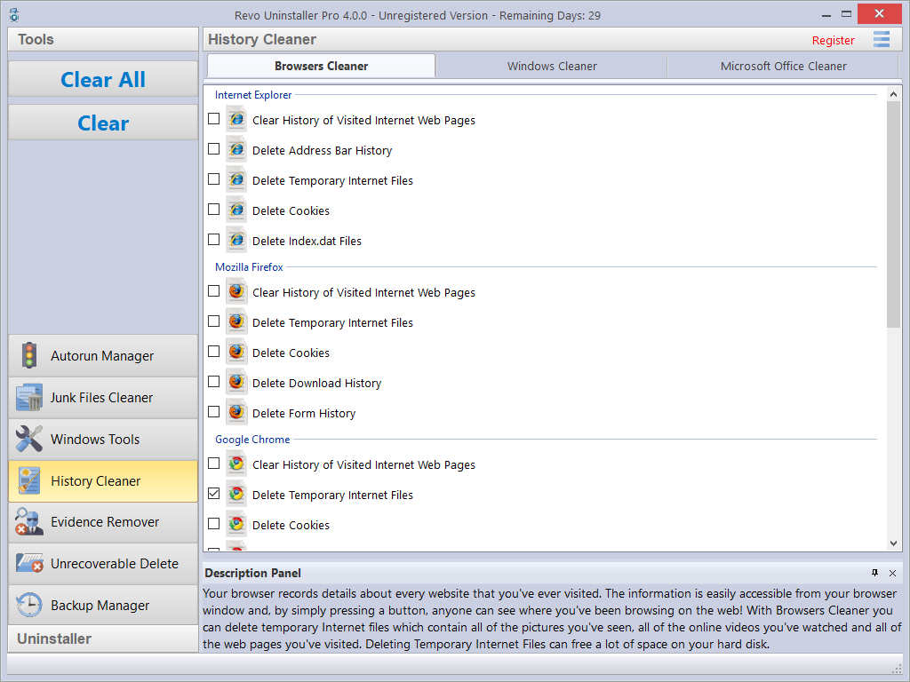

Browsers Cleaner - Your browser makes a detailed record of every web site you have ever visited. It is easily accessible from your browser window, and simply by pressing a button anyone can see what you have been browsing on the web. Revo Uninstaller Pro erases web site history of the following web browsers: Edge, Internet Explorer, Firefox, Google Chrome, and Opera. With the Browsers Cleaner, you can also delete temporary Internet files, which include images, videos, audio files, etc., all the web pages you have visited. Deleting temporary Internet files will also free a disk space on your hard disk.
Depending on the history setting, you want to clean, and the browser you have, you have to check the desired options, and click the Clear or Clear All buttons in the Commands Panel. You can also quickly check or uncheck all options for one or all browsers by right clicking, and selecting the appropriate option.
Windows Cleaner - Microsoft Windows keeps tracks of many things you do, like file search history when you search for file and folders; recently opened document history; open/save history used in standard open/save dialogs; start menu clicks history; last opened Registry key history, and more. Windows Cleaner allows you to remove all of this history and temporary files quickly and easily. You can also empty your Recycle Bin, and delete temporary files, freeing more disk space.

Available options for Windows Cleaner are:
  - Clear Recent Documents History
  - Clear Start Menu Run History
  - Clear Find File History
  - Clear Printers, Computers and People Find History
  - Empty Clipboard
  - Clear “MS Paint” Recent Files History
  - Clear “MS WordPad” Recent Files History
  - Clear “Regedit” Last Opened Key History
  - Clear Common Dialog Open Save Recent Histry
  - Clear Common Dialog Last Visited Folder History
  - Empty Recycle Bin
  - Delete Windows Temporary Files
  - Delete Start Menu Click Logs
  - Delete crash memory dump files
  - Delete Chkdsk (Check Disk) recovered file fragments
  - Delete Thumbnail Cache.

Depending on the history setting, you want to clean, and the browser you have, you have to check the desired options, and click the Clear or Clear All buttons in the Commands Panel. You can also quickly check or uncheck all options by right clicking, and selecting the appropriate option.

Microsoft Office Cleaner - allows you to remove history of most recently used files in Microsoft Word, Excel, Access, and PowerPoint. If you do not want somebody else to see your last opened or edited documents, spreadsheets, or other files created using Microsoft Office, just select those, and click the Clear or Clear All button on the Commands Panel. Your most recently used files will no longer be listed. Windows also keeps a record of your recent files. Use Microsoft Windows Cleaner to clear them too. You can also quickly check or uncheck all options by right clicking, and selecting the appropriate option.

  - Evidence Remover

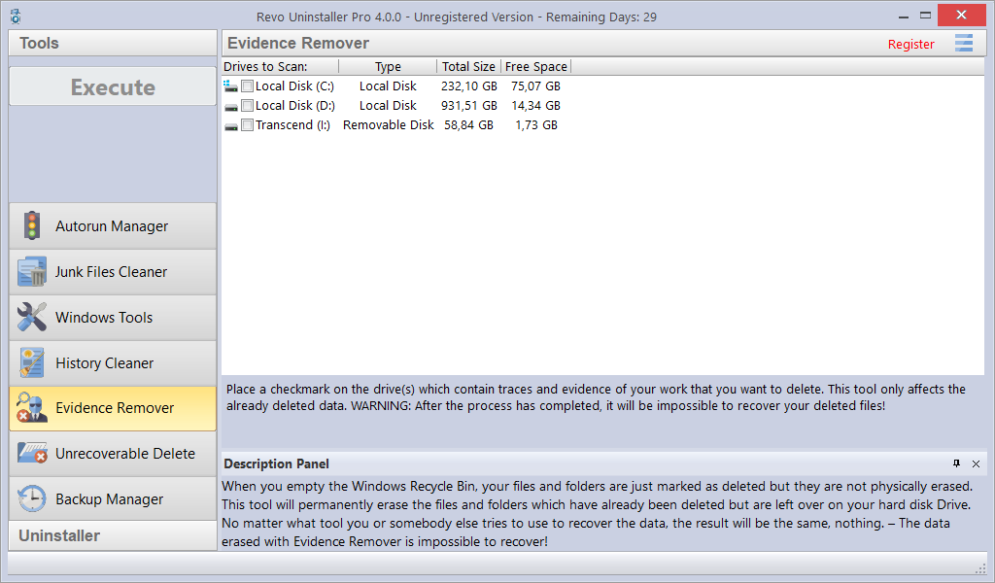

Deleting your files and folders does not mean that they are gone forever. When you empty the Recycle Bin, your files and folders are just marked as deleted but they are not physically erased. There is a chance to recover deleted data from 10 years or older computers, and this data may be very important or confidential. You can easily get back your important documents and other files that you have deleted using any recovery tool or un-delete program. This is where the Evidence Remover comes in. The Evidence Remover will eliminate all chances to get data back from your hard drive(s). It will forever erase files and folders that are already deleted, but left physically on your hard disk. No matter what tool you or somebody else uses to recover data, including professional and expensive recovery tools, the result will always be the same — the data erased with Evidence Remover is impossible to recover.

To erase already deleted files and folders, you have to check the drive from which those files were deleted, then you have to click the Execute button in the Commands Panel. Once you start the procedure, you will see a window with a progress bar and the estimated remaining time of the operation. You will also have the option to Pause/Resume the process.
The process can be slow, because the data is overwritten randomly three times. The overall speed depends on:
- your computer’s processor (CPU);
- the size of the selected drive;
- any running programs;
- any running security software – antivirus, Internet Security, etc.

During the process, the free disk space decreases because Evidence Remover creates a huge file, and writes random data in it. That huge file is deleted at the end of the process – the free disk space is restored.

  - Unrecoverable Delete

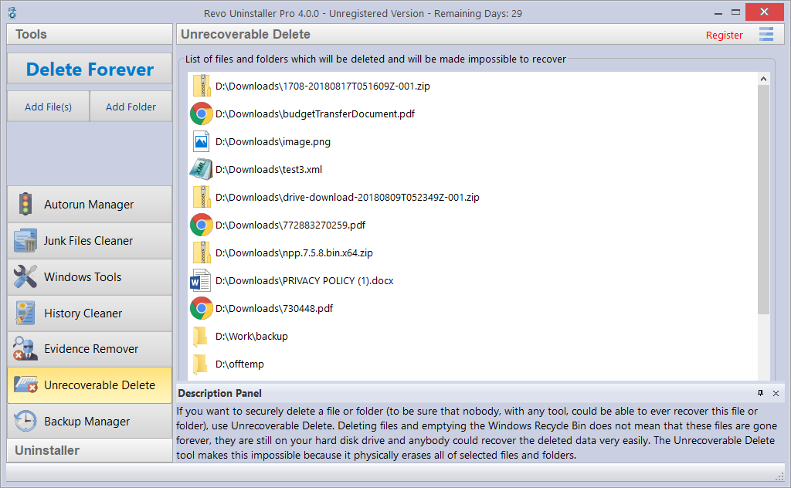

If you want to securely delete a file or folder, and to be sure that no one, with any tool, could be able to recover that file or folder, then use Unrecoverable Delete. Deleting files and emptying Windows Recycle Bin does not mean they are gone forever. They are still on your hard drive, but marked as deleted. Anyone with a file recovery tool (free or commercial), could recover deleted data easily. Revo Uninstaller Pro’s Unrecoverable Delete tool makes this impossible, even if you try to do that with the most advanced and expensive tool on the market. Deleting files in Windows means that they are marked as deleted, and the space they allocated up until that point is free to use. This is because if Windows has to physically erase all deleted files, it will take time and will slow down your computer. There is also a lot of system, temporary, and other files which are a unimportant so making them unrecoverable would be waste of resources. Unrecoverable Delete physically erases all files and folders that you choose, which is why it takes more time than simple deletion.

Unrecoverable Delete has the following commands:
- Add File(s) – use it to add a file or files that you want to erase forever.
- Add Folder – use it to add a folder that you want to erase forever. All files and sub-folders of the selected folder will be erased.
- Delete Forever – starts the erasing process. You can cancel it but the files erased before the cancelation will be unrecoverable, so please be careful when selecting the files and folders you want to erase. Once you start the procedure, you will see a window with a progress bar and the estimated remaining time of the operation. You will also have the option to Pause/Resume the process.

The window of the Unrecoverable delete tool supports drag and drop of files and folders. Because Revo Uninstaller has administrative privileges, programs with lower privileges cannot drop files and folders in it. For example, if you run Windows explorer or any other file manager with a standard user account (not as administrator), you will not be able to drag and drop files in Unrecoverable delete tool.

- Options

To open Revo Uninstaller Pro’s Options, click the Menu button in the top right corner, and select Options.

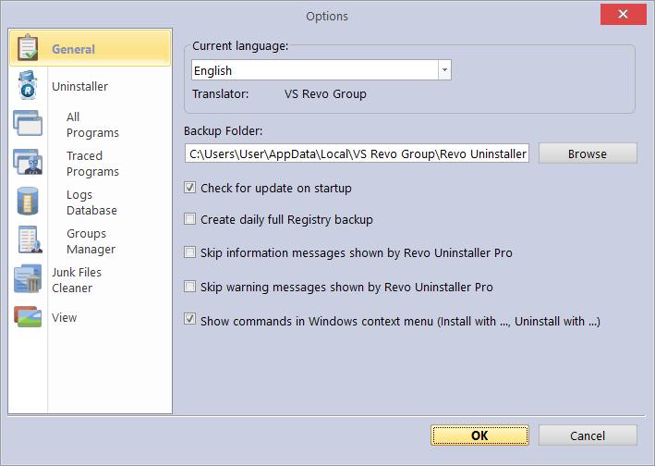

  - General

Here you can find some general options for Revo Uninstaller Pro:
Current Language: - drop down menu with all available languages for Revo Uninstaller Pro’s user interface. Note that if you had selected a specific language at the beginning of Revo Uninstaller Pro’s installation, that language will be automatically selected here.
Backup Folder: - the folder where all backups are be stored. You can change it if the currently used drive has little or no more free space.
Check for update on startup – enables Revo Uninstaller Pro to check if there is a new version available, by connecting to www.revouninstaller.com on startup, but only once a day. No personal information is sent. Note that you have to allow Revo Uninstaller Pro to connect to the Internet in your firewall.
Create daily full Registry backup – enables Revo Uninstaller Pro to create a full Registry backup once per day, the first time it is started during said day.
Skip information messages shown by Revo Uninstaller Pro – if you do not want to see information messages from Revo Uninstaller Pro, enable this option. Information messages are for example: “Revo Uninstaller Pro finished scanning for leftovers”.
Skip warning messages shown by Revo Uninstaller Pro – if you do not want to see warning messages from Revo Uninstaller Pro, enable this option. Warning messages are for example: “Are you sure you want to remove selected item?”
Show commands in Windows context menu (Install with ..., Uninstall with...) - Revo Uninstaller Pro adds the following options to the Windows context menu (right click on a file or folder):
- Install with Revo Uninstaller Pro;
- Uninstall with Revo Uninstaller Pro (for folders only).
If you want to remove these options from the context menu, uncheck this option. Because Windows shell extensions are loaded into memory, a system restart will be required for the change to take effect.

  - Uninstaller
    - General

Here are the main options affecting the whole uninstaller…
Set focus on Traced Programs on startup – when Revo Uninstaller Pro is started, the All Programs tab is shown by default; by enabling this option, Traced Programs will be shown instead.
Make a System Restore Point before uninstall – if Windows System Restore is enabled, Revo Uninstaller Pro sends a request to it to create a System Restore Point.
Create a full Registry backup before uninstall - if the option is enabled, Revo Uninstaller Pro creates a full Registry backup, which you can use to restore from via the Windows Recovery Console.
Forcibly stop running executable files during their uninstall – if this is enabled, and Revo Uninstaller Pro is trying to uninstall an executable file(s), then it will try to stop that file(s) forcibly. This will prevent some running files from remaining on the system until the next restart, or even after that.
Backup deleted Registry items – this option will cause all changes to the Windows Registry to be backed up. The backups can be restored from the Backup Manager.
Delete files and folders:
This option controls how Revo Uninstaller Pro handles the deletion of files:
- to Backup folder – all deleted files are backed up to Revo Uninstaller Pro’s own backup folder. While this option is the most secure as it ensures you will always have a backup, it can also require a lot of hard drive space if the deleted leftovers files are many and/or large.
- to Recycle Bin –moves all deleted leftovers to the Recycle Bin. This is the default option. You can easily restore any deleted leftover file until you empty the Recycle Bin, then you would need to use dedicated recovery software if you wish to restore any deleted files.
- Permanently – all leftover files and folders are deleted permanently, so you cannot restore them easily later. You would need to use dedicated recovery software if you wish to restore any deleted files.
Show as new programs installed:
Control how recently installed a program must be in order for it to be listed in the “New Programs” section of All Programs.
- Last (in days) – you can specify how many days after a program’s installation it should be considered as a new program.
- Since the last startup of the uninstaller – a program is shown as new only once – the first time Revo Uninstaller Pro is run after the program’s installation; after that it is no longer considered new.

  - All Programs

Options here are related to the All Programs tab in the Uninstaller.

    - General

- Show system updates – enables the listing of Windows updates;
- Show system components – some programs have additional components, which are removable but marked as a component of another program, and by default, Revo Uninstaller Pro does not list these kind of programs.
- Use program's uninstall data to get the Install Date property - if this option is enables, Revo Uninstaller Pro reads the installation dates of installed programs from their own uninstallation data in the their uninstallation Registry key. Otherwise, Revo Uninstaller Pro reads the installation date from the Registry in its own, proprietary way.
- Only run the built-in uninstaller - disables scanning when uninstalling a program.
- Search for an appropriate log before program's regular uninstall - if this option is enables, when uninstalling a program through the All Programs module,
Revo Uninstaller Pro will search for an appropriate log among your logs and the logs in the Logs Database, in order to do a better uninstallation.
- Open the Uninstall wizard maximized – enabling this option will make the window containing leftovers to always be shown maximized, for better review of the listed items.
- Check mark all leftovers by default - leftovers such as Registry entries, files, and folders found by Revo Uninstaller Pro will be checked/selected automatically. NOTE: When you click the Delete button, items that are both checked and in bold will be deleted, even if all items have checkmarks!
- Rebuild cache file – this option rebuilds cache file, which contains data about the installed programs. Revo Uninstaller Pro re-reads the information in the Registry, and re-creates the cache file. This will also remove any customization you may have made: comments, custom icons, and groups.

    - Registry

When a program from the All Programs tab is uninstalled, Revo Uninstaller Pro shows the leftover Registry entries and some of the items we know for sure that are not created by the uninstalled program, so we have an exclude list for these items. You are also able to add or remove such items (using Add and Remove buttons), to restore the default list of exclusions by clicking Reset Defaults.

A Registry key can be excluded only by adding the full path to the key. For example:
HKEY_LOCAL_MACHINE\SOFTWARE\Classes

There is an option for each Registry key called Include Sub keys. It will exclude all sub-keys of that Registry key as well.

In front of each Registry key there is a check box, which is used to enable or disable the exclusion of the corresponding Registry key. If there is a check mark, the key is excluded.

The exclusion list supports wildcards, such as (?) and (*), which means you can exclude several keys at once, or without knowing the exact name of a particular key. For example:
HKEY_LOCAL_MACHINE\SOFT????\Classes
This will exclude all Registry keys inside HKEY_LOCAL_MACHINE, beginning with “SOFT” and having exactly four characters after “SOFT”, because the (?) sign means any character.

HKEY_LOCAL_MACHINE\SOFT*\Classes
This will exclude all Registry keys inside HKEY_LOCAL_MACHINE, beginning with “SOFT”, regardless how many characters there are after “SOFT” and what they are, because the * character means anything/everything. For example:
HKEY_LOCAL_MACHINE\*\Classes
This will exclude all keys that are inside HKEY_LOCAL_MACHINE, and that have sub-keys “Classes”. i.e. the following keys will be exluced:
KEY_LOCAL_MACHINE\SOFTWARE\Classes
HKEY_LOCAL_MACHINE\HARDWARE\Classes
HKEY_LOCAL_MACHINE\Microsoft\Classes
HKEY_LOCAL_MACHINE\Your Company\Classes
HKEY_LOCAL_MACHINE\Anything goes here\Classes

You can also use a combination of (?) and (*).

    - Folders

It is also possible to exclude folders from the leftover scans. From the Folders tab, you can add or remove folders to the exclusion list using the Add and Remove buttons, or restore the default list of exclusions by clicking Reset Defaults.

  - Traced Programs
    - General

When you install a program through Revo Uninstaller Pro, it creates a log file. These log files are saved to a default folder, which can be changed if needed. The Logs Folder: field shows the current path to the logs; it can be changed to a different folder by typing the path manually, or by clicking the Browse button, and selecting the new folder.
- Delete traced program log after uninstall – if the option is enabled, after a program is uninstalled using a log file via the Uninstall command (not the Custom Uninstall command), the log file used is deleted.
- Trace programs in compact mode – by default, when tracing a program installation, the trace bar is located at the top of the screen and runs across the entire screen. Enabling this option switches to a smaller, floating trace bar that is on top of all other windows. Use this if you dislike the default behavior, or if you are having problems with it.

    - Exclude

When a program from the All Programs tab is uninstalled, Revo Uninstaller Pro shows the leftover Registry entries and some of the items we know for sure that are not created by the uninstalled program, so we have an exclude list for these items. You are also able to add or remove such items (using Add and Remove buttons), to restore the default list of exclusions by clicking Reset Defaults.

A Registry key can be excluded only by adding the full path to the key. For example:
HKEY_LOCAL_MACHINE\SOFTWARE\Classes

There is an option for each Registry key called Include Sub keys. It will exclude all sub-keys of that Registry key as well.

In front of each Registry key there is a check box, which is used to enable or disable the exclusion of the corresponding Registry key. If there is a check mark, the key is excluded.

The exclusion list supports wildcards, such as (?) and (*), which means you can exclude several keys at once, or without knowing the exact name of a particular key. For example:
HKEY_LOCAL_MACHINE\SOFT????\Classes
This will exclude all Registry keys inside HKEY_LOCAL_MACHINE, beginning with “SOFT” and having exactly four characters after “SOFT”, because the (?) sign means any character.

HKEY_LOCAL_MACHINE\SOFT*\Classes
This will exclude all Registry keys inside HKEY_LOCAL_MACHINE, beginning with “SOFT”, regardless how many characters there are after “SOFT” and what they are, because the * character means anything/everything. For example:
HKEY_LOCAL_MACHINE\*\Classes
This will exclude all keys that are inside HKEY_LOCAL_MACHINE, and that have sub-keys “Classes”. i.e. the following keys will be exluced:
KEY_LOCAL_MACHINE\SOFTWARE\Classes
HKEY_LOCAL_MACHINE\HARDWARE\Classes
HKEY_LOCAL_MACHINE\Microsoft\Classes
HKEY_LOCAL_MACHINE\Your Company\Classes
HKEY_LOCAL_MACHINE\Anything goes here\Classes

You can also use a combination of (?) and (*).

In case you see in your logs files and/or folders that shouldn’t be deleted, the best approach is to find out which process is responsible for their addition to the log, and exclude said process by adding it to the exclusion list. You are also allowed to add specific files and folders to be excluded from the logs. Using the Add and Remove buttons in the Files and Folders to Exclude section.

    - Processes

When a program is installed through Revo Uninstaller Pro, some of processes should always be monitored and logged. You can add processes to be included in the monitoring using by clicking the Add button, and either specifying the full path to the process, or clicking Browse, and selecting it. You can also Remove added processes, or just uncheck them. The Reset Defaults button will remove all added processes by the user, while simultaneously restoring the default ones.

Exclude Processes works in the same way as Include Processes, except that processes in this list are not monitored during the installation of programs.

  - Logs Database

Options here are related to the Logs Database Module.

Automatically update the Logs Database - if this option is checked, the local database file that contains the available logs is automatically updated. From here, you can always update it manually by clicking the Update Now button. You can also see the current version of the database file on your computer and the latest version of the database stored on our server.

  - Groups Manager

The Groups Manager shows all available groups for both All Programs and Traced Programs. The group order is important because it is considered during program listing – the groups are shown in All Programs and Traced Programs in the same order they are listed in the Groups Manager. Clicking the header of the list will sort all groups alphabetically. You can use to the Move Up and Move Down buttons to change the order of the groups to your liking. There are also other buttons:
- Add – used to add a new group.
- Rename – used to rename a selected group in the list.
- Remove – used to remove a selected group from the list.
- Reset Defaults – removes all user created groups, and restores the default groups, which are Internet, Games, Multimedia and Utilities.

  - Junk Files Cleaner

    - General

Delete files to the Recycle Bin - if this option is enabled, all junk files are moved to the Recycle Bin, instead of being deleted permanently. This can be considered as an additional safety measure, but will not free up disk space until you empty the Recycle Bin.

Ignore files accessed last 24 hours - this option is enabled by default because some junk and temporary files are in use during the scan, so it is better to ignore them.

There is a list of patterns (mostly file types), and their description, where you can select which pattern to look for when scanning for junk files. Files, matching a given pattern, will be shown in the results list only if corresponding pattern is checked (enabled).
You can also add or remove patterns by using the buttons underneath. To add a new pattern, click the Add button. A small window will appear, where you can type the desired pattern using wild cards (?) and (*).
To remove a pattern, select it in the list, and click the Remove button. If you want to restore the default built-in patterns, just click the Set Default button, which will delete all user created patterns, and restore the default ones.

    - Exclude

If you wish to exclude any files contained within a directory from a junk scan, there is a list of patterns of paths on the local drives, where you can select which pattern (folder) to be skipped when scanning for junk files. Directories matching a given pattern will be skipped during the scan process only if corresponding pattern is checked (enabled).
You can also add or remove patterns by using the buttons underneath. To add a new pattern, click the Add button. A small window will appear, where you can type the desired pattern using wild cards (?) and (*).
To remove a pattern, select it in the list, and click the Remove button. If you want to restore the default built-in patterns, just click the Set Default button, which will delete all user created patterns, and restore the default ones.

    - Include

In the Include tab, you can add folders, whose entire content is to be considered junk during a scan, thus also deleted.
Note: all files contained in the explicitly included directories will be considered junk, regardless of their extensions, so be careful to include only such folders, for which you are certain they do not contain any actual, personal data.
  - View

Some visual aspects of Revo Uninstaller Pro can be changed and adjusted here.

    - General

From the options here, you can turn on the Show small icons in Details view option, if you want to view small icons in the Details view of the Uninstaller modules and the Autorun Manager.
Show startup splash screen – enables or disable the splash screen shown while Revo Uninstaller Pro is loading. This will not speed up the loading process, only remove the splash screen.
Reset main window panels settings - resets the position and size of the panels in the main Revo Uninstaller Pro window – control bars, status bar, description panel, etc.
Reset Details view control settings - resets any customization (all column changes) of the Details view mode for modules that use it: All Programs, Traced Programs, Autorun Manager, etc.

    - Theme

Revo Uninstaller Pro supports basic themes, which can be changed here. There is a drop-down menu, from which you can choose from several pre-defined visual themes. Beneath the aforementioned drop-down list there are two buttons that allow you to make a custom theme with your favorite colors. The Custom Background Color lets you choose a custom color for the background of all windows in Revo Uninstaller Pro, and the Custom Selection Color lets you choose a custom color for all selected elements in different controls and lists in Revo Uninstaller Pro.

- Registration/Activation and Update Subscription

Revo Uninstaller Pro has a 30-day free and fully functional trial period, during which you can use it without any restrictions. At any moment you can check the title bar on the top of Revo Uninstaller Pro’s main window to see how many days you have until the end of the trial period, and every time you close Revo Uninstaller Pro, you will see a trial period reminder notifying you how many days you have left. Yet another way to see the remaining trial time is to click the Menu button on the top right of the main window, and then click -> About.
When the free trial period is over, if you want to continue using Revo Uninstaller Pro, you will have to purchase a valid license from our web site – www.revouninstaller.com.
Once activated, your version of Revo Uninstaller Pro will work and will not expire, but you will be able to update it only to the latest released version during your subscription period. After that period expires, you won’t be able to install new versions of Revo Uninstaller Pro, released after the date of expiration. You can check the subscription duration of your license if you click the Menu button on the top right of the main window, and select About.
If you decide to renew the update subscription period of Revo Uninstaller Pro, but it has not yet expired, the update subscription period of the newly entered serial number will be added to the remaining days of your current update subscription period.
When you purchase a license, we send you a Serial Number with a specific update subscription period, which you must enter in the registration form in Revo Uninstaller Pro, together with a registration name (user name). There are two possible ways to activate or update subscription of Revo Uninstaller Pro - to activate it online or to activate it by a specially generated file by Revo Uninstaller Pro.

  - Activate Online

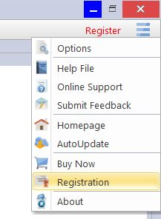
To activate Revo Uninstaller Pro online, you must first select that option in the Registration window (it is selected by default), and Revo Uninstaller Pro must have permissions to access the Internet, which means it should be allowed in your firewall.

To open the Registration/Update Subscription Form, and enter the Serial Number and your Name you have to:
- Run Revo Uninstaller Pro.
- Click the Menu button.
- Choose Registration or Update Subscription.

Another way to open the registration window is to click the Register link, on the left of the Menu button.

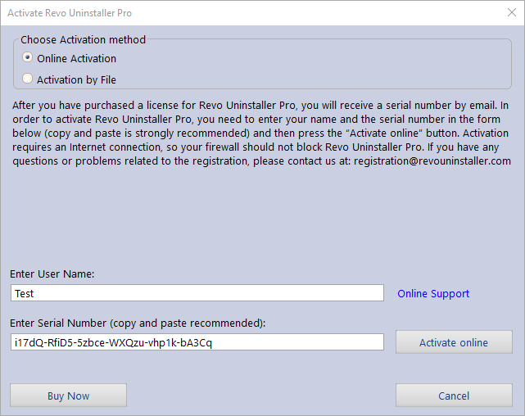

In the first field you need to enter a user name. The user name can be whatever you wish.
In the second filed you need to enter your serial number.

IMPORTANT: the serial number contains lower and upper case characters, as well as numbers, and it is case-sensitive. Thus, we recommend that you copy and paste the serial number from the received e-mail, as that is easier, faster, and more reliable than typing it manually.

After you have filled out both fields, click the Activate Online button. You will see a text in the registration window saying that Revo Uninstaller Pro is contacting its server for activation. After the activation is complete, restart Revo Uninstaller Pro to check the registration status in the title bar and the About window:
- the title bar of the main window of Revo Uninstaller Pro;
- Menu button -> About.

If the activation is successful you should see - Registered to [Your Registration Name].

The activation requires an Internet connection, because Revo Uninstaller Pro needs to contact our activation server to validate your License.

If your computer does not have an Internet connection, you have another option to activate Revo Uninstaller Pro - Activation by File.

If you have any questions or problems activating Revo Uninstaller Pro, please do not hesitate to contact us via support@revouninstaller.com or registration@revouninstaller.com. Please include details of your purchase, like full name, order ID, e-mail address, and License Key received from us.

  - Activation by File

To activate or update a subscription of Revo Uninstaller Pro by file, first you must select that option from the Registration window.

To open the Registration/Update Subscription Form, and enter the Serial Number and your Name you have to:
- Run Revo Uninstaller Pro.
- Click the Menu button.
- Choose Registration or Update Subscription.

In the first field you need to enter a user name. The user name can be whatever you wish. In the second filed you need to enter your serial number.

IMPORTANT: the serial number contains lower and upper case characters, as well as numbers, and it is case-sensitive. Thus, we recommend that you copy and paste the serial number from the received e-mail, as that is easier, faster, and more reliable than typing it manually.

After you have filled out both fields, click the Save File button. This will bring up a window that will allow you to save a .rupaf file with a name and location of your choice. After you save the file, send it to us by e-mail (to registration@revouninstaller.com), and we will send you back the Unlock Key, which you must in turn enter in the same registration form, and click the Activate button. After the activation is complete, restart Revo Uninstaller Pro to check the registration status in the title bar and the About window:
- the title bar of the main window of Revo Uninstaller Pro;
- Menu button -> About.

If the activation is successful you should see - Registered to [Your Registration Name].

If you have any questions or problems activating Revo Uninstaller Pro, please do not hesitate to contact us via support@revouninstaller.com or registration@revouninstaller.com. Please include details of your purchase, like full name, order ID, e-mail address, and License Key received from us.

  - Deactivate

In case you want to move your Revo Uninstaller Pro license to another computer, or you are changing your current computer, you can transfer your current license – deactivate it on your current computer, then activate it again on your other/new computer.

To start deactivation process follow these steps:
- Run Revo Uninstaller Pro.
- Click the Menu button (in the top right corner).
- Click Deactivate…

You will be prompted to confirm the operation, and then the deactivation will start. Note that the license deactivation requires an Internet connection. If you do not have an Internet connection, or your firewall blocks Revo Uninstaller Pro, the deactivation will be unsuccessful, and you will see a notification. In such a case, when you want to deactivate your license, but are unable to, please contact our support team for assistance. You can contact us via support@revouninstaller.com or registration@revouninstaller.com with details of your purchase.
Deactivating your license will disable the installed copy of Revo Uninstaller Pro on the computer, on which you have deactivated your license. Should you choose to activate on the same computer again, instead of activating on a different computer, you can do that. You will receive a message when you start Revo Uninstaller Pro on that same computer that the license was deactivate, and you can simply activate again.

- Command Line support

Revo Uninstaller Pro supports command line options and has a command processor: RevoCmd.exe.

RevoCmd.exe can be used to list installed programs on a computer. It can be used to list programs by a part of their name, and it can also show the installation location and the uninstallation command of a program, which can be then used to start its built-in uninstaller.

Usage:
RevoCmd /m "program name" [/i] [/u] [/p]
/m - match program name using wildcard characters - * and ?
The asterisk (*) wildcard represents any combination of characters.
The question mark (?) wildcard represents any single character.
Example: RevoCmd /m Microso*
Shows all programs beginning with Microso
/i - include installation location, if it exists
/u - include uninstallation command
/p - pause on each page
/? or /help - this help

Some Revo Uninstaller Pro operations can be executed from a command line. Supported command line operations and their arguments are:

Regular Uninstall - you can uninstall programs listed in Revo Uninstalle. The uninstallation process does not start the built-in uninstaller of the selected program, instead it automatically deletes Registry entries, files, and folders found as leftovers and created by the program.

Syntax:
RevoUninPro /mu "Program name" /path "Full program path" /mode "uninstall mode" /32

Where the parameters are:
/mu - exact name of the program, as it is listed in Revo Uninstaller Pro.
/path - full path to the program's installation folder. The path must not end with a backslash character (\).
/mode - mode of the uninstallation - Safe, Moderate, or Advanced.
/32 or /64 - depending if the program is 32-bit or 64-bit.

Example:
RevoUninPro /mu "Yahoo Toolbar" /path "C:\Program Files\Yahoo Toolbar" /mode Moderate /32

Traced Uninstall - you can uninstall traced a program using the name of its trace log. The uninstall process reverts all logged system changes.

Syntax:
RevoUninPro /tu "Log name"

Where the parameters are:
/tu - exact name of the log file, as you have saved it after tracing the program’s installation, i.e. as it is listed in Revo Uninstaller Pro.

Example:
RevoUninPro /tu "Yahoo Toolbar"

Export - you can export the lists of all installed programs and all traced programs. All details/properties are included in the exported files.

Syntax:
RevoUninPro /export "Full export path" /all /traced /txt /xls /html

Where the parameters are:
/export - full path to the export file, and where the exported information will be stored.
/all - export the “All Programs” list.
/traced - export the “Traced Programs” list.
/txt - export the information in a text file (.txt).
/html - export the information in an HTML file (.html).
/xls - export the information in a Microsoft Excel spreadsheet (.xls).

Note: for the export to a Microsoft Excel spreadsheet to work, you need to have Microsoft Excel installed and functioning properly.

Example:
RevoUninPro /export "C:\My data\allprograms.txt" /all /txt

Hunter Mode - you can start Revo Uninstaller Pro in Hunter Mode.

Syntax:
RevoUninPro /hunter

- Restore Full Registry Backup

Revo Uninstaller Pro creates a full Registry backup once each day it is started. It also, by default, creates a full Registry backup on each program uninstallation. This can be disabled in the Options. The full Registry backup is done in addition to the regular backups of all Registry entries that Revo Uninstaller Pro deletes.

Full Registry backups should be used only if the Backup Manager cannot restore removed items, or if Windows does not start properly anymore!

Depending on your operating system, the steps to restore a full Registry backups are as follows:
  - Windows Vista and Windows 7

1. Restart the computer. When the machine first starts again, it will generally list some equipment installed on your machine, amount of memory, hard drives installed, etc. At this point you should tap the F8 key repeatedly until you are presented with a Windows Advanced Options menu.
2. On top of the menu, select the "Repair Your Computer" option.
3. You will then have to go through a few steps until you see the System Recovery Options window.
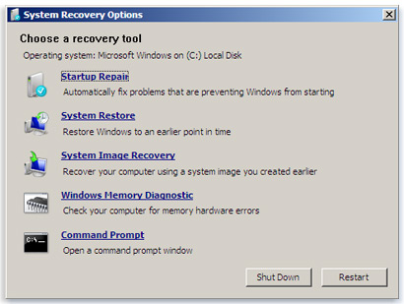
4. If you want to restore Revo Uninstaller Pro’s full Registry backup, you have to select the Command Prompt option.
Enter (type) each of the following commands (in bold), and press Enter after each one:
(Assuming you have installed Windows on “Local Disk (C :)”)
Step 1: C:
Step 2: CD Users
Step 3: DIR
(A list with folder names will appear, you will see your user name, remember it for the next step.)
Step 4: CD “XXX\AppData\Local\VS Revo Group\Revo Uninstaller Pro\RegBackup\Daily\”
OR
Step 4: CD “XXX\AppData\Local\VS Revo Group\Revo Uninstaller Pro\RegBackup\Last\”
(Replace XXX with the user name you saw in the previous step. Also, include the quotation marks above.)
There may be two folders with a full Registry Backup. The first folder is named Daily because it is created once a day. The second is created on each uninstallation of a program. If you are sure you want to restore full Registry backup created before a program uninstallation, use the second option for Step 4 – Last.
Step 5: ren Restore.dat Restore.bat
Step 6: Restore.bat
  - Windows 8 and Windows 10

You have to start the computer in a special mode with Command Prompt. To do that, restart your computer as you normally would, but before you initiate the reboot, press and hold the Shift key. Hold the key down until the computer restarts and you see the Choose an Option screen.
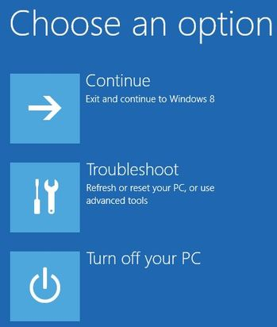
Then follow these steps:
1. Click the Troubleshoot button.
2. Click the Advanced Options button.
3. Click the Command Prompt button.
4. Log into your account, and you will see the Command Prompt window.
Enter (type) each of the following commands (in bold), and press Enter after each one:
(Assuming you have installed Windows on “Local Disk (C :)”)
Step 1: C:
Step 2: CD Users
Step 3: DIR
(A list with folder names will appear, you will see your user name, remember it for the next step.)
Step 4: CD “XXX\AppData\Local\VS Revo Group\Revo Uninstaller Pro\RegBackup\Daily\”
OR
Step 4: CD “XXX\AppData\Local\VS Revo Group\Revo Uninstaller Pro\RegBackup\Last\”
(Replace XXX with the user name you saw in the previous step. Also, include the quotation marks above.)
There may be two folders with a full Registry Backup. The first folder is named Daily because it is created once a day. The second is created on each uninstallation of a program. If you are sure you want to restore full Registry backup created before a program uninstallation, use the second option for Step 4 – Last.
Step 5: ren Restore.dat Restore.bat
Step 6: Restore.bat
- Frequently Asked Questions (FAQ)
  - General questions

I have used the contact form on your website but I haven’t received an answer yet. How long should I wait for support?

Our support team will contact you within 24 hours after receiving your message. Usually the response time is between a few minutes and several hours depending on the work load of our support team. If after 24 hours you still haven't received a reply, then please send your query again, and be sure that your e-mail address is correctly written.

I am a registered user of Revo Uninstaller Pro 3.x, and just bought an upgrade to version 4. Should I uninstall the old version first before installing the new one?

We do not recommend you uninstall version 3 before installing the new version 4 because you will lose your current settings and other user data. The best approach is to install the new version over the existing version, as it will overwrite it, and you will keep your data and settings, just as it happens with minor updates.

What is the difference between Revo Uninstaller Pro setup version and Revo Uninstaller Pro Portable?

The main differences between the standard (installable) and Portable versions of Revo Uninstaller Pro, are the licensing type and the portability of the Portable version. The licensing of the standard version is per computer, whereas for the Portable version it is per user. The standard version has a license that is per computer. This means that a license is purchased for a certain amount of computers but any user who uses those computers is also allowed to use Revo Uninstaller Pro. The portable version has a license per user. This means that one user is allowed to use Revo Uninstaller Pro on unlimited number of computers (just not simultaneously). The portable version is designed to be run directly from an external USB device (like a thumb drive), without leaving any traces on the computer’s hard drive or Registry, on which it is run. That way you can have a copy of the program with you.

I have Revo Uninstaller Freeware installed, and I bought the Pro version. Should I uninstall the Freeware version before installing the Pro?

Both versions of Revo Uninstaller - Freeware and Pro - are installed in different folders, and are completely independent. They do not share common components or modules. So it is not a problem if you have installed the Pro version while the Freeware is still on you system, but the Pro version is superior, so you will not need the Freeware version anymore.

Why "Pin to" is missing on Revo Uninstaller Pro's shortcut and it cannot be pinned to Windows 7 taskbar or start menu?

The reason for this is that Windows 7 does not allow pinning programs containing the word "install" in their name. You can solve the problem by creating a shortcut on your Desktop of Revo Uninstaller, and rename it to just "Revo", or anything else that does not contain “install” as a word or part of a word.

Is Revo Uninstaller Pro compatible with 64-bit versions of Windows?

Yes, Revo Uninstaller Pro is fully compatible, and natively supports of all 64-bit versions of Windows, starting with Windows Vista and up to the latest Windows 10.

Why should I use Revo Uninstaller Pro when I have a registry cleaner, and it fixes all errors in my Windows Registry?

There are tens of thousands of applications that leave a lot of unused data, such as registry entries, files, and folders in your computer. Not all registry keys left in your computer are errors, and third-party registry cleaners cannot detect them. Leftover registry keys in combination with leftover files make registry cleaners’ job impossible. Revo Uninstaller Pro helps you remove the leftover registry keys, files, and folders after uninstalling an application.

How can I close or move the Hunter Mode window?

To close the small blue target window, which appears in the upper right corner of the screen when you are in "Hunter Mode", you have to click with the right click it, and choose Exit, or Open Main Window.
To move it, you have to click and hold it with the middle (scroll) mouse button, then you can drag it to the desired position on your screen.

I am tracing an installation of a program with Revo Uninstaller Pro, but the program's installer asks me to restart the computer. How should I proceed?

If you see such message or request for a reboot, our advice is to stop the tracing process, and save the log with Revo Uninstaller Pro (on a system restart if the tracing of Revo Uninstaller Pro is active it will save the log with a default name automatically), and to restart your computer. For most programs, you will have a reliable log file, as in such cases all the program data is already installed, and the program needs a reboot in order to start its services or modules that are going to be started on every Windows start up.

  - Registration and licensing questions

Is the license of Revo Uninstaller Pro a lifetime license?

Purchasing a License for Revo Uninstaller Pro 4 or above includes free technical support and free updates while your update subscription is valid (not expired). For example, if your update subscription expires on 1 January 2021, you can install for free any version of Revo Uninstaller Pro released before 1 January 2021. After that date, if you want to install a newer version, released after 1 January 2021, you would have to renew your update subscription. Depending on features in new versions, you can decide to renew your update subscription by purchasing an updated license (significant discounts will be applied), or to continue using your already purchased version. You can continue using your activated version, for which you have purchased a license, for as long as you want.

I bought a license for Revo Uninstaller Pro for one computer. On how many computers can I activate the program?

Licensing of Revo Uninstaller Pro is per computer, so buying a license for one computer allows you to register the program on only one computer. If you want to buy a license for 3 or more computers, or if you already are our customer, you will be able to buy additional licenses at a discount.

What kind of license for Revo Uninstaller Pro do I need if I have installed more than one copies of Windows versions on my computer (dual/multi boot)?

You need a license for only one computer as all your Windows installations are on the same computer. You should not have problems registering the program on any of the supported by the program versions of Windows.

During the registration process, I saw a message "Registration failed". How to proceed?

If there is a problem with the registration, and you see such a message, it should be followed by a sentence with a reason for the problem or with an error code. Contact our support team with the information about the failed registration, and we will assist you to solve the problem.

I have changed my computer, and now I can't activate Revo Uninstaller Pro on my new computer. What do I do?

We apologize for the inconvenience, but you will have to contact our support team to reset your activation on the server. We treat such requests with priority, so it usually takes from a few minutes to a few hours, and always less than 24 hours.

  - Uninstall (remove) programs related questions

How to uninstall programs with Revo Uninstaller Pro?

Before uninstalling a program, make sure that it is not running. Check the system tray (in the Taskbar, near the clock) any icons belonging to the program you want to uninstall. If such icons are there, try right clicking them, and look for an option like "Exit", "Quit" or something similar. Select the program in Revo Uninstaller Pro, and click the Uninstall button. Revo Uninstaller Pro will start the uninstalling wizard, which will guide you through the process. During the uninstallation, Revo Uninstaller Pro will try to run the built-in uninstaller of the program you want to uninstall. If it works properly, let it to do its job. If it is not working properly, you should see an error message, and you will have to skip (ignore) it. Then you proceed to the leftover scan by clicking the "Scan". After the scanning completes, Revo Uninstaller Pro will list all leftover Registry entries, files, and folders to review, verify and, delete.

How to uninstall a traced program with Revo Uninstaller Pro?

If you have monitored the installation of a program with Revo Uninstaller Pro, then the best way to uninstall it is to use the created by Revo Uninstaller Pro log. To access it, open the Traced programs module. Before uninstalling a program, make sure that it is not running. Check the system tray (in the Taskbar, near the clock) any icons belonging to the program you want to uninstall. If such icons are there, try right clicking them, and look for an option like "Exit", "Quit" or something similar. Select the program in Revo Uninstaller Pro, and click the Uninstall button. A window will show you the progress of the operation, and when that window disappears, the program will be uninstalled.

How to uninstall a program if I see that there is a log for that program in the Logs Database?

Uninstalling a program using a log from the Logs Database is the same as if you uninstall this program using your own log. Just select the program in the Logs Database list, and click the Uninstall button. This will automatically download the selected log, import it in Revo Uninstaller Pro, and start the uninstallation procedure.

Is there a way to undo an uninstallation of a program?

Reinstalling the program is the first and easiest solution. Because Revo Uninstaller Pro automatically creates a System Restore Point before uninstalling a program, you can use the System Restore feature to restore your system to a previous state. You can access System Restore in Revo Uninstaller Pro: click Tools -> Windows Tools-> Windows System Restore. By default, Revo Uninstaller Pro moves all leftover files to the Recycle Bin when you delete them, so check there for accidentally deleted files. Also by default, Revo Uninstaller Pro backs up every deleted leftover Registry item, so check the Backup Manager for any backups of deleted Registry entries you want to restore.

How can I stop/remove a program from the Windows system tray?

Revo Uninstaller Pro has a unique feature called "Hunter Mode: 1. Switch to "Hunter Mode" - a blue window with a crosshair will appear in the upper right corner of the screen. 2. Drag (hold the left mouse button) the blue target window to the system tray, and locate the program you wish to remove 3. Drop (release the left mouse button) on the target - a menu will appear. Then you can select "Kill Process", and it will disappear from the system tray. There are other options you may want to use such as: Uninstall, Stop Auto Starting, Properties, Open Containing Folder, etc.

Why can't I uninstall programs without admin rights on Windows Vista/7/8/10?

You cannot uninstall programs if you do not have administrator privileges because uninstalling programs involves removing files, folders, and Registry entries from various protected system locations on your hard drive and Registry. The standard user account is designed to only have privileges to run/use most programs.

How can I remove a program, which when I try to uninstall using Programs and Feature or Revo Uninstaller Pro, I see the same error message?

Most likely, this error message is generated by the built-in uninstaller of the program you want to uninstall, which both the Programs and Features applet and Revo Uninstaller Pro try to run during the uninstallation procedure. In most cases, Revo Uninstaller Pro can handle the uninstallation process even if the built-in uninstaller of the program is not functioning properly. In that case, you should start the uninstallation procedure with Revo Uninstaller as usual, and when you see that error message, you can simply skip (ignore) it, click the Scan button to start scanning for the leftovers of the program, and continue forward to review and delete the found leftover data.

How can I remove a program, which is not listed in Programs and Features (Add or Remove programs) or Revo Uninstaller Pro?

If the program is not listed in Revo Uninstaller Pro, you try our Forced Uninstall feature, which does not require a program to be installed or listed properly. Start the Forced Uninstall feature, enter the program’s exact name and/or point to its folder on the hard drive, and proceed with the scan.

How to proceed if the program's own built-in uninstaller asks to reboot the computer after an uninstallation?

The best approach is to decline the reboot request, search for leftovers with Revo Uninstaller Pro, delete any leftovers you deem unnecessary, then finally reboot your computer.

Can I use Revo Uninstaller Pro to uninstall accumulated updates for Microsoft Windows?

If any updates are listed in Revo Uninstaller Pro, you should be able to uninstall them without issue. However, their installation and removal is too critical for the operating system, and it should be handled only by the built-in functionality in Windows.

I used Programs and Feature application to uninstall a program several months ago. Can Revo Uninstaller Pro still find possible leftover items so I can delete them?

If the program is not listed in Revo Uninstaller Pro, you try our Forced Uninstall feature, which does not require a program to be installed or listed properly. Start the Forced Uninstall feature, enter the program’s exact name and/or point to its folder on the hard drive, and proceed with the scan.

I am trying to uninstall a program, but during the uninstallation procedure, the built-in uninstaller of the program is reinstalling/repairing it instead of uninstalling it. How to proceed?

Cancel the build-in uninstaller of the program and the uninstall wizard of Revo Uninstaller Pro. Then, in the list of installed programs, right click the program in question, and select the Forced MSI Uninstall command, which will start the uninstall procedure again, but the built-in uninstaller will try to uninstall the program, instead of repairing it.

  - Logs Database module related questions

What is the Logs Database?

This is a database of logs of traced programs through the monitoring module of Revo Uninstaller Pro. The Logs Database is created and maintained by Revo Uninstaller Pro's team. The logs are stored on our web server, and you can use them to uninstall programs or to remove leftovers of previously uninstalled program.

How to uninstall a program if I see that there is a log for that program in the Logs Database?

Uninstalling a program using a log from the Logs Database is the same as using your own log. Just select the program in the Logs Database list, and click the Uninstall button. This will automatically download the selected log, import it in Revo Uninstaller Pro, and start the uninstallation procedure.

Can I use a log from the Logs Database to uninstall a different version of the program from the log?

It depends on the program, and how much it has changed across different versions. In most cases, you should be able to properly uninstall a program with a version similar to the one of the log. For example, if you have Skype 5.2 installed on your computer, you should be able to uninstall it properly even using a log for Skype 5.1. That is because of the "Advanced Uninstall" technology applied when a traced program is uninstalled through a log. It searches for data related to the uninstalled program that may not have been recorded in the log.

  - Questions related to other cleaning or optimization tools

How can I scan with the Junk Files Cleaner for a specific file type?

Go to Options -> Junk Files Cleaner -> General, and check if the specific file type is in the list, and if it is checked. If the file extension is not listed, click the Add button, enter the specific file type in the newly appeared window, and click OK to confirm. Start the Junk Files Cleaner, and click the Scan button to start scanning.

How can I stop programs that start automatically on Windows startup?

In the Autorun Manager, you have to uncheck the program you want to disable. Conversely, to enable it, simply check it back again.

